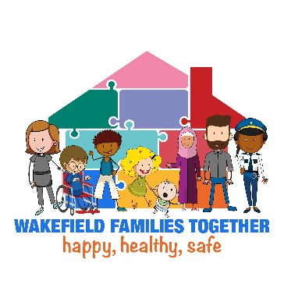
Request for Early Help Form
Before completing the Request for Early Help form, you may wish to contact the Family or Youth Hub Duty or, if you are a school, your EIP Link Worker.  They will be happy to offer advice and guidance on whether the Team Around approach is the most appropriate pathway for the family. | 

Please ensure the family have been provided with full details of the Team Around and Family and Youth Hub Offers, along with the Wakefield Families Together Privacy Notice.

Wakefield Families Together Privacy Notice WFT-privacy-notice-may-2025.pdf

Team Around The ‘Team Around’ approach – Wakefield Families Together

Family and Youth Hub Offers Wakefield Families Together – Wakefield Families Together

Please share with the family:
- that the Team Around meeting is made up of professionals, for example, this could include; Early Intervention & Prevention Service, FiM - Mental Health Support Team, Education Improvement Teachers, WISENDSS Inclusion Advisory Teachers, the School Nurse, school, and VSCE.
- that professionals will share their records to inform discussions so that, a whole family support package can be identified. They will make a record on their systems to capture them having done this.
- that the family can withdraw from the support provided at any time.

SHOULD BE COMPLETED ELECTRONICALLY
To be Completed by the Nominator with the Family

Individual | DOB | Contact | Ethnicity | SEND  state if there is SEMH, an EHCP, MSP, OPP, or if it is Section 23 notification. | School Attendance % | Young Carer?  yes/no | Lives in the same household as the Child?  yes/no | Agreement Obtained from Family to Access Health Records?  yes/no
Child’s name:

Home Address:
Siblings name:

Siblings name:

Siblings name:

Parent/carer name:

Parent/carer name:

For additional siblings, duplicate rows

GP and address of surgery: | Details of any health concerns:
Parents’ views, what support would help:

Child/young person’s views, what would they like to happen:

SHOULD BE COMPLETED ELECTRONICALLY
To be Completed by the Nominator

Please indicate if this request is for:

- Team Around the Early Years ☐
The child and their family need support and a single intervention will not be enough, and the child is too young to have started school.

- Section 23 Notification ☐
For Health Professionals only, please include rationale below.

- Team Around the School ☐
The child and their family need support and a single intervention will not be enough, and the child is on the roll of a Wakefield school.

- Team Around the School (including Future in Mind) ☐
The child and their family need support and a single intervention will not be enough, and the child is on the roll of a Wakefield school. There are identified support needs in relation to mental health, details must be provided below, and the family have agreed to the child’s health information being shared as part of the Team Around process.

- Young Futures Team Around ☐
Team Around the School is not appropriate, but single agency intervention will not be enough to address need. It may be appropriate to refer to the Young Futures Team Around, for example, when a child is not on roll at a school.

Children, young people, and families currently open to Targeted Early Help, Children’s Social Care, or the Youth Justice Service are not eligible for the Team Around and their lead worker should be contacted.

Nominating Partners Details

Nominator name and job title: |  | Organisation:
Email address: |  | Contact number: | Date form completed:
Families Local Family or Youth Hub Details

Hub: | EIP link worker (if known): | Meeting date (if known):
What are you worried about?
What’s working well?
What have you tried?
What would you like to see happen?

SHOULD BE COMPLETED ELECTRONICALLY
Family Agreement

The process cannot progress until you confirm that the family has agreed to their information being shared with partners as part of the Team Around Process.

Please tick to confirm that all the information provided has been discussed with the family and that they have agreed to you sharing the above with partners as part of the Team Around meeting, report, and discussions ☐

Please tick to confirm that the family have been directed to, and understand the Wakefield Families Together Privacy Notice ☐

Please submit to the family’s local Best Start Family Hub or Youth Hub
Full and up to date details of the interventions and activities offered can be found at Wakefield Families Together – Wakefield Families Together

