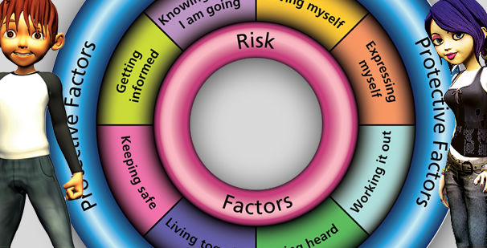
Wakefield Resilience Framework Opportunity to join the training team

www.riskandresilience.org.uk
Information session: 11.30am, 19th October 2022, MS Teams
Are you passionate about developing resilience in children and young people?
Do you want to support colleagues to develop their skills and knowledge in this area?
The Resilience Framework is used across the Wakefield district to promote and develop resilience in children and young people. This evidence-based approach has been used successfully for over 12 years and we are looking to expand our training team to ensure we develop and maintain a consistent approach to promoting resilience and reducing the risk of adverse outcomes for children and young people.
This document outlines the expectations of new members of the training team along with the support on offer to develop you in this role.
The trainer role will be carried out alongside your day job. (See information for managers for further details).
Train the Trainer expectations | Training delivery expectations
You will attend 3 sessions where you will observe, co-deliver and be observed. We are flexible in the delivery of this training in order to meet the needs of the organisation being trained, therefore training sessions vary from 2 hour sessions to full day sessions. | Once you have been through the train the trainer you will be expected to co-deliver 4 sessions per year. Sessions vary from 2 hour sessions to full day.

Post training support
We know that how people are supported after their training has a big impact on the effectiveness of the training. We will therefore encourage trainers to share areas of good practice and challenges. You will also be invited to participate in and take a lead in post training support for those who have received the practitioner training. Through these communities of practice, we will ensure that practitioners are supported when using the framework.
Find out more
This opportunity is open to practitioners working with children and young people across the Wakefield district – in Children’s Services, Schools and Voluntary and Community Sector.
To find out more or to receive an invitation to the information session on 19th October please contact:
Denise Wheatman  dwheatman@wakefield.gov.uk  07500890605 | Sarah Flynn  sarahflynn@wakefield.gov.uk  07824 335596
Information for managers
This is a great opportunity for practitioners to deepen their understanding of the Resilience Framework and to be able to offer their knowledge and support to wider colleagues and networks. The benefits are numerous:
- Deepen their knowledge of the Resilience Framework
- Develop their network across the Wakefield district
- Learning opportunity to develop training skills, both face to face and online
- Provide support to your own team/service in terms of using the framework
Time Commitment
2022/23 – Attendance at 3 Train the Trainer sessions.
We are flexible in the delivery of this training in order to meet the needs of the organisation being trained, therefore training sessions vary from 2 hour sessions to full day sessions. Sessions will always be planned in advance so that backfill can be arranged or workload planned to accommodate this.
Following the Train the Trainer period each trainer will be required to deliver 4 sessions per year and spend 1 day per year attending group supervisions/good practice sharing networks. Each trainer’s ‘training year’ will begin from the first date that they co-deliver following their train the trainer sessions.
Finance
Funding will be provided to backfill the time dedicated to the Train the Trainer sessions and to subsequent delivery of training.
Service Level Agreement
A service level agreement will be put in place between Public Health and your service/organisation to provide clarity in terms of time required and funding to be provided.

