
Empowering SEND Support in Wakefield

Wakefield Safeguarding Children Partnership (WSCP) is running a district wide campaign on Safeguarding Children with Special Educational Needs and Disabilities (SEND) from 3rd November 2025.

Key messages include:
- Explore the SEND toolkit
- SEND. Safeguarding every child starts with understanding their needs
- Understand, empower and safeguard children with SEND
- Explore neurodiversity, complex care needs and non-verbal communication to reduce risk of harm to a child
The WSCP has developed a NEW SEND toolkit to help those who work or volunteer with children with SEND so they can safeguard vulnerable children from harm, abuse and exploitation.
Why are we running a campaign on Safeguarding children with SEND?
Learning from safeguarding audits and reviews has told us we need to better embed how we safeguard the most vulnerable children in Wakefield. A child with SEND can be more vulnerable to harm for a variety of reasons and it is everyone’s responsibility to ensure we know what to look out for, how to support the child and family and which services can help.
Throughout this year WSCP and the SEND team have developed a range of new resources for those who work or volunteer with children with SEND. We have a new Toolkit to aid the practitioner in a variety of SEND topics where they can find all the local and latest information relating to SEND provision, guidance and support in one place.
The resources and information available are:
- Toolkit on the WSCP website – SEND - Wakefield Safeguarding Knowledge Hub
- 9 One-minute guides from our new SEND series One Minute Guides - Wakefield Safeguarding Children
- Additional training on complex care needs - slides to either add to single agency training or to read through separately Explore Complex Care Needs - Wakefield Safeguarding Knowledge Hub
- 7PB Concerning a child with complex health needs dated July 2024
What is the purpose?
All the resources aim to raise awareness and provide guidance about how to safeguard vulnerable children with SEND in the district.
These resources should be used in several ways:
- For personal professional development
- Team meetings / peer support sessions
- Part of single and multi-agency training
- Reflect on as part of supervision
How can you help?
You can help by supporting the campaign, using and sharing all the resources which have been developed.
You can do this by:
- Sharing messages and graphics through internal newsletters, website, and emails to staff about the campaign
- Share key messages and graphics on your service social media accounts and across your networks
- Share and disseminate the toolkit to your networks
- Provide an opportunity for staff to review the resources and supporting guidance available in supervision and team briefings
- Following the WSCP account on X (previously Twitter) and resharing and liking our posts
To help you do this we have provided the following:
- Suggested key messages to promote with social media graphics (please see below)
- social media graphics to promote with the key messages
- Intranet Banner & Screensaver
- A choice of email signature graphics

Graphics (download by right clicking and clicking ‘save as’)
Intranet Banners:
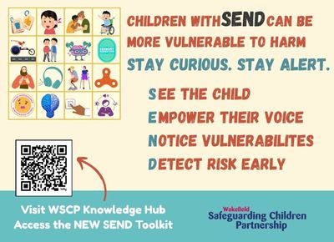
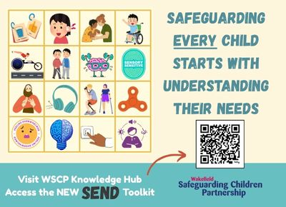
Screensavers:
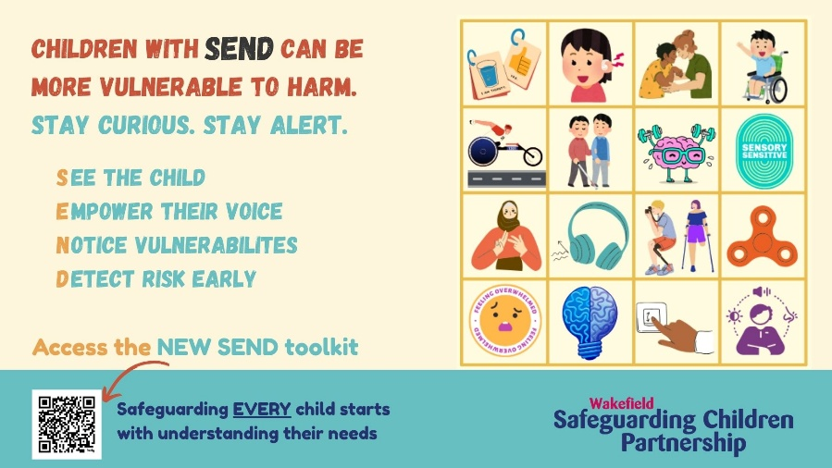
Email signatures
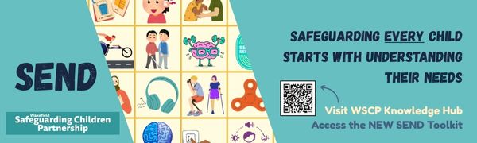
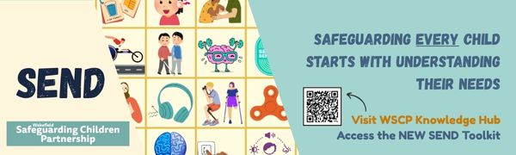
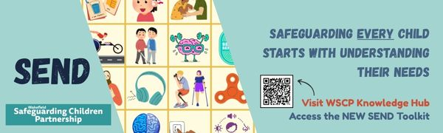

Twitter Posts
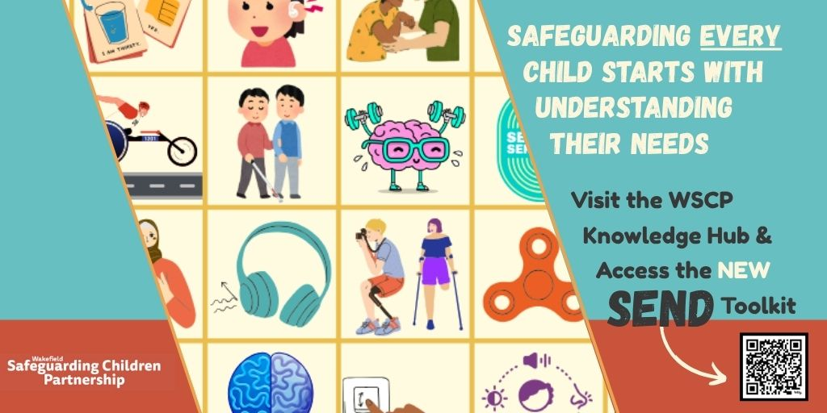
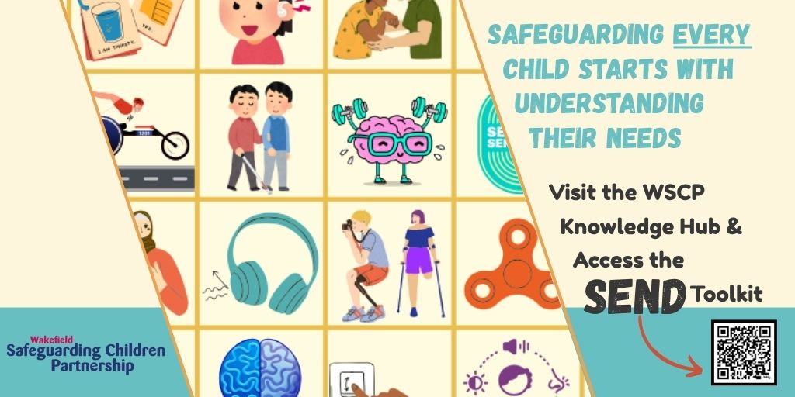
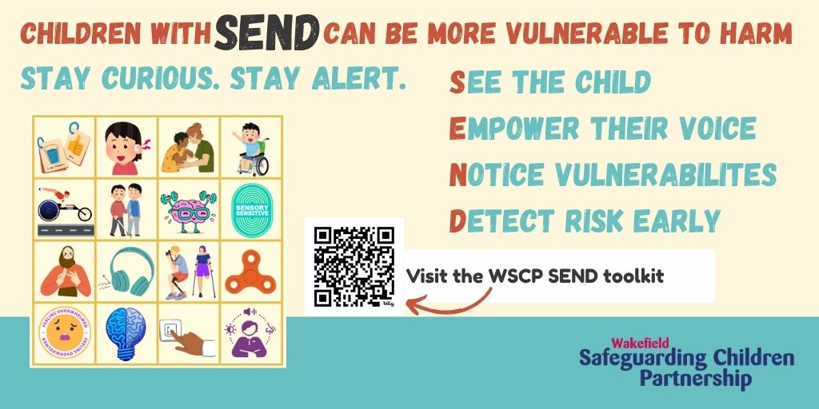

Messages (to use with the above graphics)
- 🌟 New Resource Alert!
The Wakefield SEND Toolkit is now live – your go-to guide for supporting children and young people with SEND.
🧩 One-minute guides
🧠 Neurodiversity & communication strategies
📘 Practical tools for practitioners
👉 Explore the toolkit
#WakefieldSEND #SENDSupport #InclusionMatters
--------------------------
- 🗣️ This week’s spotlight: Non-Verbal Communication
Discover strategies to support children who communicate in different ways.
📘 One-minute guides
💡 Practical tips for practitioners
🔗 Visit the SEND Toolkit
#SENDToolkit #WakefieldPractitioners #InclusivePractice

- 🗣️ This week’s spotlight: Neurodiversity
Understand how to better support children who thrive in different ways.
📘 One-minute guides
💡 Practical tips for practitioners
🔗 Visit the SEND Toolkit
#SENDToolkit #WakefieldPractitioners #Neurodiversity
--------------------------
- 🗣️ This week’s spotlight: Complex Care Needs
Explore the challenges and develop systems to better safeguard children with complex care needs.
📘 One-minute guides
💡 Practical tips for practitioners
🔗 Visit the SEND Toolkit
#SENDToolkit #WakefieldPractitioners #ComplexCareNeeds
--------------------------
- Have you explored the WSCP SEND Toolkit yet?
Whether you're in education, health, or social care – this resource is built for YOU.
✅ Quick guides
✅ Practical strategies
✅ Local relevance
📲 Access it now
#SENDSupport #WakefieldSCP #LearningTogether
--------------------------

- Did you know that children with SEND can be more vulnerable to harm?
Stay curious & alert. Recognise their lived experience and give them a voice.
✅ See the child
✅ Empower their voice
✅ Notice vulnerabilities
✅ Detect risk early
📲 Access the toolkit now
#SENDSupport #WakefieldSCP #EmpowerSEND
--------------------------

Resources to download / link to
- Page on the WSCP website – SEND - Wakefield Safeguarding Knowledge Hub
- Series of SEND One-minute guides
- For more information on this campaign and to see our previous campaigns visit WSCP Campaigns page

Who to contact
If you have any questions regarding this campaign, please contact WSCP – wscp@wakefield.gov.uk

