

Safeguarding Children and Young People

Policy and Procedures

**This has been reviewed and agreed by the Yorkshire Sport Foundation Board on 15th November 2023**

##### The policy is available on the YSF website.

**Context**

Yorkshire Sport Foundation is a charitable Company and this policy covers all aspects of the Charity’s work and its subsidiaries.

Yorkshire Sport Foundation has a responsibility to protect children and young people and we are committed to improving safeguarding processes across sport and physical activity. We have a responsibility for advocating and influencing partner organisations to provide safe systems for safeguarding children and young people.

The welfare of young people is the primary concern and we believe that everybody, whatever their age, culture, disability, gender, racial origin, religious belief and sexual identity have the right to protection from abuse.

This document is informed by the HM Government “Working together to safeguard children 2018” guide to inter-agency working, and conforms to the Standards for Safeguarding Children in Sport (revised 2018)

The practices and procedures within this policy are based on the principles contained within UK legislation and Government Guidance and take the following into consideration:

* The Care Act 2014
* The Protection of Freedoms Act 2012
* Domestic Abuse Act 2021
* Domestic Violence, Crime and Victims (Amendment) Act 2012
* The Equality Act 2010
* The Safeguarding Vulnerable Groups Act 2006
* Mental Capacity (Ammendment) Act 2019
* Sexual Offences Act 2003
* The Human Rights Act 1998
* The Data Protection Act 2018
* UK GDPR 2020
* Keeping Children Safe in Education 2023
* After-school clubs, community activities and tuition: safeguarding guidance for providers 2023

This policy applies to all Yorkshire Sport Foundation staff and volunteers. It details procedures and standards that we advocate for external organisations who we work with and/or fund. Crucially, it recognises that all individuals have a duty of care to provide a safe environment and protect children and young people from abuse.

Yorkshire Sport Foundation’s work has been categorised to ensure that appropriate safeguarding procedures are understood and adhered to:

1. Us as an organisation
2. Commissioned work
3. Event management
4. Supporting the network

**Overall responsibilities**

Across all of work the Charity will:

* Accept the moral and legal responsibility to implement procedures to provide a duty of care for everyone, safeguard their well-being and protect them from abuse.
* Ensure an open and inclusive culture that enables safeguarding, equality and diversity issues to be addressed.
* Make safeguarding a priority for the business and have an identified Safeguarding lead and internal working group.
* Ensure an effective implementation plan is reviewed and evaluated annually.
* Embed safeguarding within contractual agreements for activities that include children and young people.
* Require all staff/volunteers to adopt and abide by the Safeguarding Policy and Procedures.
* Recruit, train and supervise its employees and volunteers to adopt best practice to safeguard and protect people from abuse, and reduce the likelihood of allegations being made.
* Respond to any allegations appropriately and implement the appropriate disciplinary and appeals procedures where it concerns Yorkshire Sport Foundation staff.
* Promote and advocate wider guidance and legislation to partners.
* Pass on information re safeguarding concerns to statutory agencies and/or other organisations (e.g. sports, schools, facilities) in line with these procedures and information sharing guidance.
* Have the arrangements in place to collaborate and to work effectively with the safeguarding partners as required by any local safeguarding arrangements, e.g. if approached to be a relevant agency will have arrangements/staff in place to fulfil this role.

**Assurance**

The Charity has a dedicated Safeguarding lead and an internal safeguarding group which meets at least twice a year to draw up an annual implementation plan and review progress. The plan will highlight the action that needs to be taken, by whom, how and when in order to implement the Charity’s Safeguarding Policy and Procedures.

The implementation plan will be shared with the Charity’s board members and they will be updated with the progress. This plan is also peer reviewed by the Child Protection in Sport Unit and the Ann Craft Trust.

The Charity is committed to the CPSU Safeguarding Framework process as outlined below.

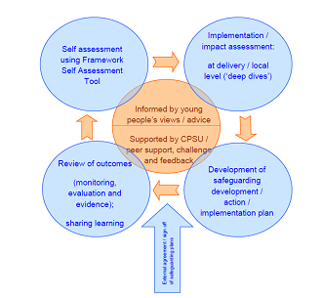

Reviewing and evaluating is a crucial part of the process and we may choose to evaluate levels of awareness and knowledge, perceptions and attitudes, behaviour and skills as well as incidents and processes. The internal safeguarding group will take decisions on the appropriate methods for reviewing implementation. The CEO and Board champion will be consulted as appropriate.

The purpose for the implementation plan is to ensure we have identified priorities and are making progress against these. It provides assurance to the team, the Board and partners that we are compliant with national requirements for safeguarding.

This safeguarding policy will be reviewed at least every two years. Where there are legislation changes, changes to Yorkshire Sport Foundation roles or function, or a significant incident occurs then the policy will be reviewed more often. The review will be carried out by the internal safeguarding group. The policy will then be taken to the CEO and Board for approval. All staff of the Charity will be given a briefing and a copy of the updated policy.

**Safeguarding Structure:**

* Board Champion
* Chief Executive Officer
* Designated Safeguarding Leads
* Internal Safeguarding Team
* Internal DBS group
* All staff

**Overview of roles and responsibilities:**

|  |  |  |  |  |  |
| --- | --- | --- | --- | --- | --- |
| Board Champion | Chief Executive Officer | Designated  Safeguarding Leads | Internal  Safeguarding Team | Internal  DBS group | All staff |
| Review and support the implementation plan | Approve the implementation plan | Lead the development of the implementation plan | Action the implementation plan | Case Management | Raise any concerns following the reporting procedures |
| Support Board Training | Ensure policy is adhered to | Plan staff training | Lead and advocate safeguarding across the organisation | Review DBS requirements for a job role | Undertaking regular training |
| Approve the policy and ensure it is adhered to | Case Management | Ensure policy is adhered to | Develop and review appropriate policies | Assess information using a risk assessment model | Promoting safeguarding standards across all work areas |
| Be the safeguarding ‘voice’ at board level |  | Decision to share information / reporting |  |  |  |
|  |  | Case Management |  |  |  |
|  |  | Coordinate Safe in Sport Forums |  |  |  |

* 1. **Organisational services**

This refers to the different organisational policies and procedures that The Charity has in place that contribute towards safeguarding of children and young people.

**Recruitment, Employment and Deployment of Staff and Volunteers**

All reasonable steps will be taken to ensure unsuitable people are prevented from working in the sport and physical activity environment. The Charity is committed to undertaking criminal records checks when required by law, or when roles are otherwise eligible.

The Charity has a clear and robust recruitment policy that is adhered to, this includes ensuring that:

* Yorkshire Sport Foundation’s open and positive stance on safeguarding is clear.
* Listing of past career or relevant experience.
* The names of at least two people (not relatives) from the Applicant’s previous 5 years of employment willing to provide written employment references that comment on the applicant’s previous experience and suitability for the role.
* The requirement that a DBS check will be undertaken if it the post meets eligibility criteria. In the case of establishing a DBS enhanced disclosure, the Charity will write to the individual requesting that they provide sight within 21 days of the written request. The Charity has the discretion to vary the timing of this requirement as it sees fit and will follow procedures outlined in the Recruitment of Ex Offenders Policy

**Induction**

All staff have an induction in which:

* Safeguarding procedures are explained and training needs established
* Good Practice Guidelines and Code of Conduct are shared.
* They are briefed, given a copy of and agree to adhere to the Charity’s policies

**Training**

Appropriate safeguarding training is mandatory for all paid and volunteer staff to ensure they are aware of their duties and competent to report and manage concerns.

All paid staff will receive appropriate introductory safeguarding training – either UK Coaching or Local Safeguarding Partnerships within 3 months of their employment. Training is refreshed regularly.

The designated safeguarding lead and deputies will receive appropriate training e.g. Time to Listen training related to the role and this is refreshed on a regular basis. They also attend Lead Officer update sessions coordinated by CPSU and the Ann Craft Trust.

Annual training may include:

* Review of reporting procedures
* Recognition of Poor Practice, Abuse and Bullying
* Scenario situations
* Refresher training

**Complaints Procedures**

The Charity’s complaints and appeals procedures will be used to deal with any formal complaints (including safeguarding issues) from external stakeholders and/or appeals. We will strive to ensure that parents and young people are aware of the existence of these procedures.

The procedures are available on our website for external agencies to access.

**Disciplinary Procedures**

The Charity’s disciplinary procedures will be invoked where a case warrants the use of disciplinary measures.

**Promoting Good Practice**

Good Practice Guidelines and examples to create a positive culture in sport and physical activity are outlined in appendix B.

These are issued to all staff working for The Charity as part of the induction process and staff are required to sign to abide by them.

**Supporting policies and procedures**

The Charity has a number of policies and procedures than run alongside the Safeguarding children’s Policy, these are:

* Safeguarding Adults Policy
* Stress at work Policy
* Complaints Policy
* Mental Health Policy
* Diversity & Inclusion
* Disciplinary Procedure
* GDPR / Data Protection
* Bullying and Harassment Policy
* Disclosure in Public Interest Policy
* Ex-offenders policy
* Personal information / photography policy

**Commissioned work:**

It is a requirement that all organisations receiving funding from the Charity will have appropriate safeguarding policy and procedures in place and meet the minimum operating standards for sport and physical activity.

**Funding agreements:**

All funding agreements related to children and young people include:

* A safeguarding commitment statement which all funded parties sign.
* Confirmation that the funded organisation adheres to the 2018 UK GDPR regulations and has appropriate consent to share the personal data of all participants related to the project with Yorkshire Sport Foundation and trusted partners. This includes parental / guardian consent for any participant under the age of 13 and appropriate consent from the individual for those aged 13+.
* Where we adopt a contact tendering process we have a governance checklist which organisations need to evidence against. A safeguarding policy and DBS checked staff (if appropriate) are included within this.

**Participant Consent:**

We have a CYP privacy notice (Appendix K) which details The Charity’s responsibility to keep personal information safe.  Personal information is anything that allows us to identify an individual such as a name or address.  We must keep this information secure and not pass it on to anyone else without consent unless there is an emergency.

All participation data that we collect and share is anomymised. However, through our work we often demonstrate impact with personal stories and we have policies which outlines the use of personal information, photographic and video images of children and young people. This ensures we have appropriate consent to store and share this information as in line with the Data Protection Act 2018. This includes the use of images on our website, social media and promotional materials.

**Minimum Operating Standards checklist (Appendix F)**

All funded projects that include sport and physical activity delivery have to submit a Minimum Operating Standards Checklist before funding is released. 'Minimum Operating Standards' are defined as the basic standards a sport and physical activity deliverer needs to meet to be able to carry out their role safely and effectively.

**Event management**

The charity acknowledges the duty of care to safeguard and promote the welfare of young people who attend events organised by ourselves.

To ensure the ongoing Safety at our organised events, we will:

* Ensure robust safeguarding arrangements and procedures are prioritised at every stage of event planning.
* Ensure everyone understands their roles and responsibilities in respect of safeguarding at events. This is through pre-event communications including event manuals, briefings for staff, volunteers and schools.
* Follow our recruitment and selection procedures
* Include specific welfare training for all event staff
* Appoint a nominated safeguarding lead during events.
* Ensure staff follow the procedure for reporting concerns
* Implement the photography policy and clearly communicate where photos and videos will be used.
* Not hold individual participant information.
* Ensure there is sufficient first aid provision.

The safeguarding at events policies and procedures will be promoted and are mandatory for everyone involved in events to read and understand. Failure to comply with the policy and procedures will be addressed without delay and may ultimately result in dismissal or exclusion from events.

**Supporting the network**

The Charity has a responsibility to promote and advocate wider guidance and legislation to partners:

**Safe in Sport Forums**

We coordinate network meetings across South Yorkshire and West Yorkshire at least twice a year. Together we work with partners to establish and implement agreed consistent minimum safeguarding standards for sports activities locally and support those working in sport by giving them knowledge, guidance and raising awareness of what they need to do to protect these vulnerable groups and minimise avoidable risks.

**External Training**

We organise regular Safeguarding training for local clubs and organisations to access.

**Reporting procedures:**

The reporting procedures is the same across our work to ensure consistency and to avoid confusion.

**Flow Chart for Reporting Concerns (i.e. staff, coaches and volunteers)**

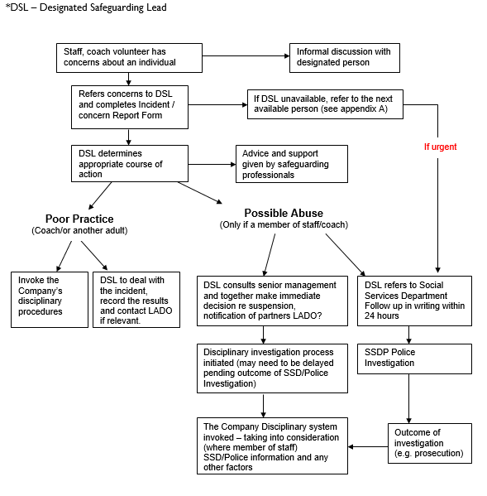

**Glossary of terms:**

**Paid staff**: core team of full and part time paid officers employed by the Charity. These officers do not necessarily have direct contact with participants however, each post will be assessed on an individual basis.

**Volunteers**: refers to one-off event staff that assist with events typically in an unpaid capacity. These people will not have unsupervised access to members of the public and will not be working on a regular basis.

**Parents:** is used throughout this document as a generic term to represent parents, carers and guardians.

**Child:** a person under the age of eighteen years

(the Children’s Act 1989 defines a young person as under 18 years of age)

**Safeguarding children:** protecting children from abuse and neglect, preventing the impairment of children’s health or development, ensuring that they grow up in circumstances consistent with the provision of safe and effective care, and taking action to enable all children to have the best life chances.

**Appendices**

Appendix A Contact Details

Appendix B Safeguarding Staff Code of Conduct

Appendix C Types and Recognition of Abuse

Appendix D Use of personal information & Photo consent form

Appendix E Incident / Concern Record Form

Appendix F Minimum Operating Standards checklist

Appendix G Protocol for Information Sharing

Appendix H Questions to ask to inform safe information sharing practice

Appendix I: Flowchart of key principles for information sharing

Appendix J: Definition of Regulated Activity

Appendix K: How to Record a Disclosure

Appendix L: CYP Privacy Notice