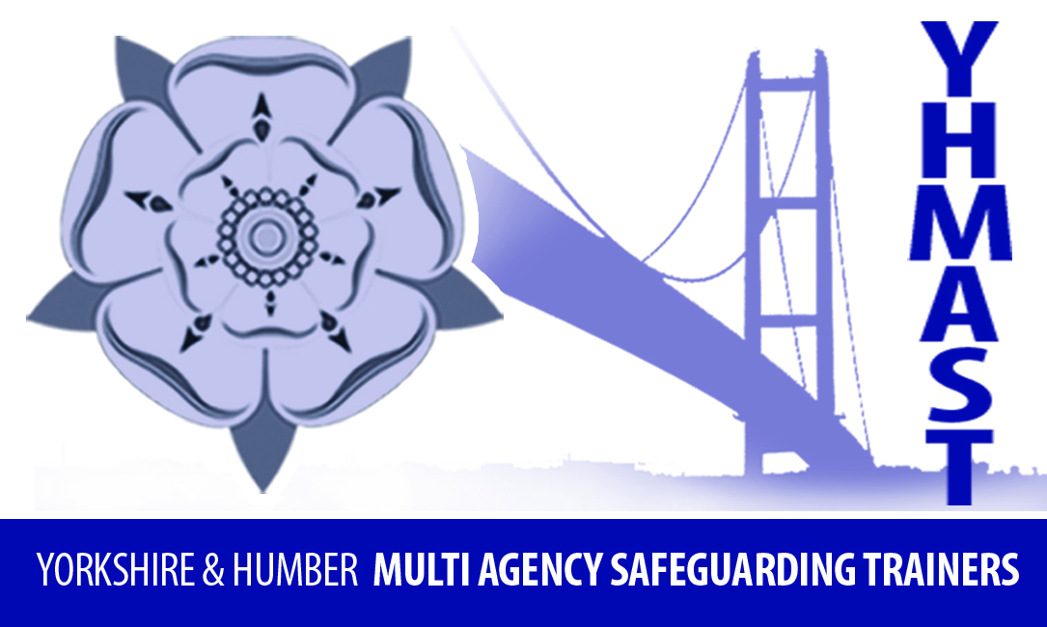

Multi-Agency Safeguarding Children Training standards
These training standards have been adopted by members of YHMAST (Yorkshire & Humber Multi-Agency Safeguarding Trainers) to reflect good practice and encourage a minimum standard in relation to delivery of child safeguarding training. The standards are based on those developed by PIAT (Promoting Inter-Agency Training) in 2003 and adapted more recently by CAPE (Child Protection in Education). YHMAST agrees with their original aim - to prevent abuse and ensure that outcomes for children were improved by providing effective continuing professional development - and has adapted them to reflect recent developments in safeguarding children training.

Standard 1 | Trainers will have a working knowledge and recent experience of safeguarding practice and at least one trainer will be a suitably qualified* or experienced trainer (*this may include attending relevant Training for trainers programme or undertaking an adult teaching/training qualification)
Standard 2 | Training content and delivery will make clear that the child’s welfare is paramount and incorporate the voice of the child, their rights and needs
Standard 3 | Training has clear aims and objectives / learning outcomes, is well planned and has a positive impact on practice
Standard 4 | Training is informed by current research, is evidence-based and includes lessons learnt from serious case reviews / child safeguarding practice reviews
Standard 5 | Training is linked to current and evolving local, regional and national standards
Standard 6 | Training promotes inter-agency/partnership working and the importance of information sharing and working collaboratively with others.
Standard 7 | The training will promote and enable practice, which is culturally aware, respects diversity, promotes equality, is anti-racist and is anti-oppressive.
Standard 8 | The trainer will, by liaising with the commissioner where relevant, ensure that the training environment is conducive to learning, safe and inclusive for all participants, taking into account their diverse needs whether this be face-to-face or online
Standard 9 | Training content will be regularly reviewed and evaluated to ensure standards are being maintained and that there is a positive impact on practice in the long and short term
Standard 10 | Materials / resources are clear, accurate, relevant and up to date, and take account of adult learning styles
Standard 11 | All training encourages and models appropriate challenge. The training will respect confidentiality however, trainers will recognise, act on and follow-up on any safeguarding concerns for children, adults at risk or organisations after the course
Standard 12 | Training will be delivered via the most appropriate platform for the circumstances and content including face to face, virtual and blended learning, with a bias towards methods that most effectively enable the building of multi-agency networks

