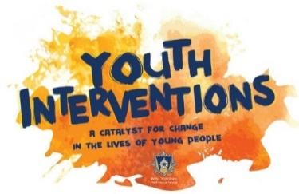
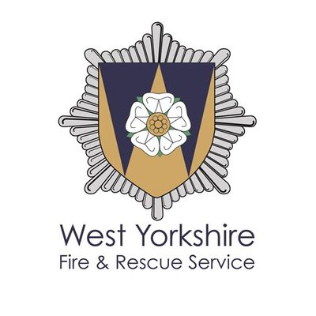

Our new intervention, ‘@E-Tude’ is a fast paced Targeted Intervention Day delivered on an operational Fire Station by WYFRS Youth Interventions Team.
During the 5 hour practical session, the group of 10 young people will have the chance to get hands-on with practical Firefighting skills & scenarios which are designed to highlight risks on the road of Power2Wheels, E-scooters and developing a safer ‘@E-Tude’ to others.
The programme incorporates a range of messages on how to be a safer rider, testing reaction times and how to make more positive choices in the future.
PPE, Resources, Risk Assessments and WYFRS staff provided.
Lunches, transport and partner staff will need to be supplied by the partner agency.
Contact Charlotte Simpson for more information on:
07760 992115 charlotte.simpson@westyorkshire.gov.uk

