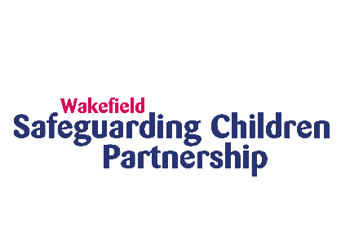
Wakefield Safeguarding Children Partnership (WSCP) is pleased to launch a district wide campaign on understanding sexual behaviour on Monday 6th November 2023.
Why are we running a campaign on understanding sexual behaviour?
WSCP has recently developed a range of new resources for those who work or volunteer with children to use when it comes to understanding sexual behaviour. As such we want to promote what has been developed via a campaign so the workforce is aware and can use these resources in their practice.
The resources and information we’ve developed are:
- A new page on the WSCP website – Understanding Sexual Behaviours describing what sexual behaviour is, the different types, where you can go for further help, why harmful sexual behaviour is a safeguarding concern, the role of the Harmful Sexual Behaviour Panel
- New One Minute Guides on Understanding Sexual Behaviour and the Harmful Sexual Behaviour Panel
- Updated Harmful Sexual Behaviour Panel Terms of Reference
- Free Multi-Agency Learning Offer on Harmful Sexual Behaviour

What is the purpose of the campaign?
The campaign aims to promote the resources available for those who work or volunteer with children and families to better understand the types of sexual behaviour in children and identify risk.
How can you help?
Supporting the district wide understanding sexual behaviours campaign launching on Monday 6th November 2023 to raise awareness of this topic and promote all of the new resources which have been developed.
You can do this by:
- Sharing information and resources on your internal service website about the campaign
- Sharing messages through internal newsletters and emails to staff about the campaign
- Share key messages and graphics on your service social media accounts
- Provide an opportunity for staff to review the resources and supporting guidance available
- Sign up to and/or promote the multi-agency harmful sexual behaviour training offer
- Following the WSCP account on X (previously Twitter) and resharing and liking our posts
To help you do this we have provided the following:
- Suggested key messages to promote with social media graphics
- 6 x social media graphics to promote with the key messages
- Intranet Banner
- Email signature graphic
- 2 x GIFs
- One Minute Guides on Understanding Sexual Behaviour and the Harmful Sexual Behaviour Panel
- Understanding Sexual Behaviours page on the WSCP website

Messages (please note message 1 links to graphic 1, message 2 to graphic 2, etc etc)
.1. The key to identifying risk, is understanding healthy sexual development in children.
Visit our website to ensure you are up to date⤵️
https://bit.ly/3QwH38K
.2. 🤔 Are you confident you understand healthy sexual development in children?
👉 If you work or volunteer with children you need to update your knowledge https://bit.ly/3QwH38K
.3. ❓ Could you confidently identify and respond to inappropriate sexual behaviour in children?
Visit our website to access the resources you need⤵️
https://bit.ly/3QwH38K
.4. @Wakeifeld_scp have resources, information and signposting to ensure you’re up to date and able to understand sexual behaviours in children and identify risks.
Visit our site for more info! 👉 https://bit.ly/3QwH38K
.5. 💻 Our website provides a list of resources for professionals working with children.
✅ Stay informed to be able to identify and respond to risks.
➡️ Visit our site >> https://bit.ly/3QwH38K
.6. A multi-agency forum that aims to support and guide professionals who work with children displaying sexually harmful/abusive behaviour.
The panel consists of experts from sectors such as social care, police, health, education, and youth justice.
Visit 👉 https://bit.ly/3QwH38K

Resources to download / link to
- One Minute Guides on Understanding Sexual Behaviour and the Harmful Sexual Behaviour Panel
- Understanding Sexual Behaviours page on the WSCP website
- Updated Harmful Sexual Behaviour Panel Terms of Reference
- NEW Understanding Sexual Behaviour Campaign – Resources and Messages

Who to contact
If you have any questions regarding this campaign, please contact WSCP – wscp@wakefield.gov.uk

