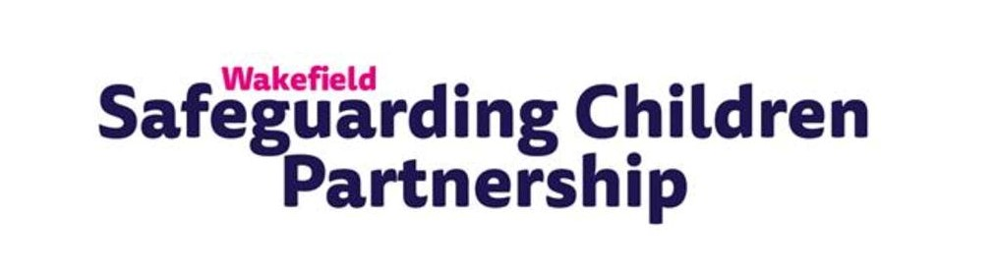

WSCP Case Study Questionnaire
Name:
You may provide a specific case name here (Please omit personal details / names):

Please note that all information shared may be used in the public domain, on our website or e-bulletin. If information is sensitive, please do not include this in your response.
The information you provide will go towards building up a library of good practice examples to share amongst your peers and amongst multi-agencies.
- Case Study: Contact details
Contact name:
Single Agency details:

Details of your role and or involvement in the case:

Key Safeguarding issue: (mental health / CSE / HSB / neglect / abuse/ bullying etc)

- Case Study: Background
Give a detailed account of the background of the case. (Omitting personal details)
Include timelines where appropriate:

- Case Study: What worked well?
Give details about which processes worked well and why.
Consider the journey from problem to solution:

- Case Study: Multi Agency focus
Detail Multi Agency joint working
Include how working collaboratively helped produce a positive outcome, give specific examples of agencies you worked with:

- Case Study: Resources
Detail any resources / assessment tools / frameworks etc used
Include how any resources helped to produce a positive outcome, give specific examples and add links where possible, this may include websites, guides, training, assessment tools etc:

- Case Study: Alternatives
Detail any other alternative ways you considered working (or in retrospect, could have considered)
Highlight joint agency approaches / exploring alternative courses of action / alternative resources / techniques.

- Case Study: Strengths and weaknesses
Detail the strengths and weaknesses in the case
This may include soft skills / engagement / experience / new ideas / professional curiosity / Trauma Informed practice / relational approach

- Case Study: Additional Info
Any other relevant information pertinent to the case
Recommendations / key learnings

Please consider attaching as many of the following to accompany your case study:
Attached with doc
Logos
Generic Images (nonspecific) – building / agency reception etc
Reports
Frameworks / guidelines
other

