Welcome to

If you are concerned about a student,
report to a member of the
Designated Safeguarding Lead (DSL) Team
as soon as possible.
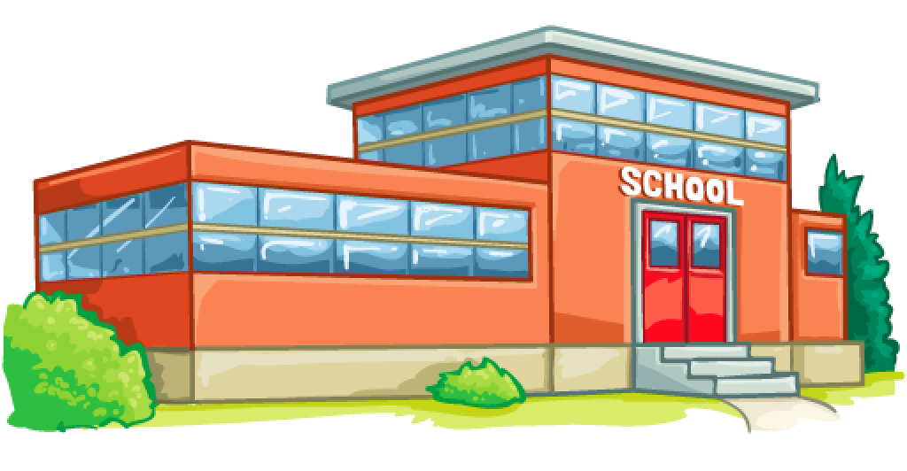



Somewhere
School

School Timetable

School starts at (X)
School finishes at (X)
(Monday and Friday) morning is whole school assembly

KS1
Morning Break 10:30—10:45
Lunch Time 12:00—13:00

KS2
Morning Break 10:45– 11:00
Lunch Time 12:30—13:15

Staff room is located (X)
Visitors are welcome to use the tea and coffee making facilities in the staffroom.
First Aid is available—where?
Staff toilets are located (X)
Visitors are not permitted to use student toilets.

A warm welcome to all visitors
Please ensure you sign in and out at reception and wear a visitors badge/lanyard at all times.
Proof of identification may be required.

In the event of a fire alarm please leave the building by the nearest fire exit, which will be identified by green exit sign and assemble (X). For invacuation procedures please seek advice from staff.

We pride ourselves on being a school with high expectations of
behaviour.
Our behaviour policy can be located (X)

If you have any safeguarding concerns about pupils please refer these to the Designated Safeguarding Lead Team—how? If you have concerns about staff conduct please report to the headteacher—how?

We expect all adults to follow the Code of Conduct for staff behaviour and
maintain professional boundaries at all times. Including best practice in lone
working with students, not using personal devices such as mobile phones when in the company of students and never sharing personal contact details, including social media.
Code of conduct can be found (x)

This is a non smoking site

