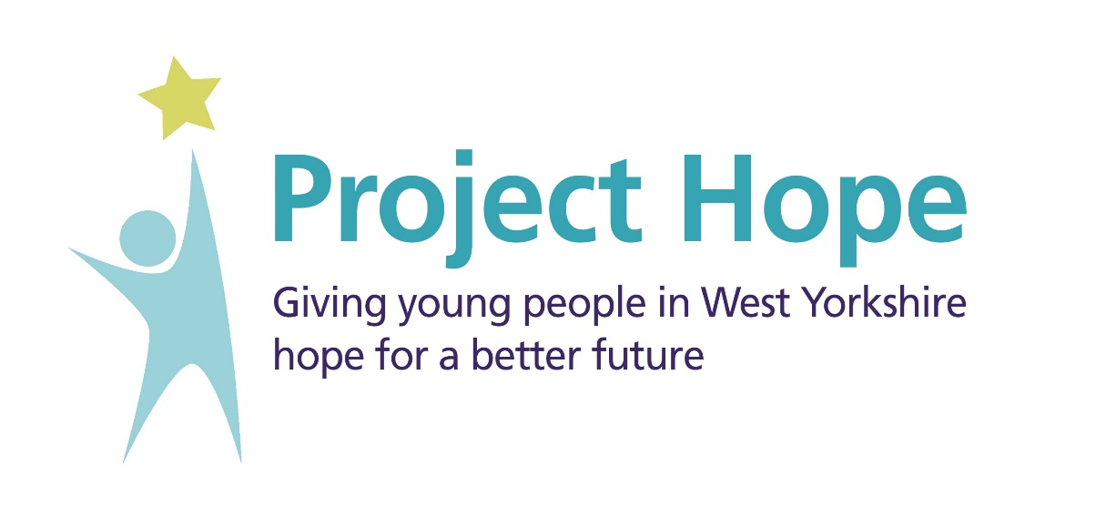
Expression of Interest
Placement Offer

About Project Hope
In January 2023, the West Yorkshire ICB were successful in securing a NHSE bid to become one of just ten ICB pathfinders across the UK. By becoming a pathfinder, we aim to build on existing practice to enable care leavers between the ages of 16 and 25 within West Yorkshire to access career opportunities across the Health and Care Sector and harness the young talent and potential that lies within the care experienced community.
We will be working in collaboration with a range of local and national partners to develop and shape the approach needed, that will see 250 care leavers across the country access employment, education and training opportunities in service by 2024. This is in line with the commitment of the Care Leaver Covenant.
Across the West Yorkshire ICB, we have an ambition to close the gaps in health and wellbeing outcomes for all children and young people across West Yorkshire, no matter where they were born, where they live, their life experiences or where they go to school.
National data obtained from the Care Leaver Covenant highlights 40% of all care leavers aged 19-21 years of age (in 2016) were not in employment, education or training compared to 14% of all 19-21 years olds. And just 7% of care leavers gained access to university, compared to the university entry in 2016 of around 40% of their peer group. The data also tells us, 20% of homeless people have previously been in care and children in care are 4 x more likely to struggle with their mental health.
These statistics highlight the stark inequalities faced by care experienced young people, and we recognise by launching Project Hope we have a key opportunity to improve access to opportunities as well as to improve experiences and outcomes for young people as we work with partners across health and care to reduce inequalities.
Project Hope aims to offer care experienced young people in West Yorkshire the opportunity to be involved in a 12-month programme of support and personal development which also includes a 6-month entry level paid placement within a Health and Care environment. The placements aim to provide opportunities for hands-on skills in the workplace, and there will also be access to a tailored pastoral offer that will include workshops to build workplace confidence in a number of key skill areas such as interviews, CV building, conflict, resilience and wellbeing and much more.
Expectations of Placement Providers
Expectations and commitment requirements have been outlined below to ensure that the placement is a suitable environment for a care experienced young person to be introduced to and work within on a 6-month paid placement. These expectations aim to support the manager, who will be the individuals main contact during the placement, as well as supporting the individual to gain on-the-job skills and knowledge. The enclosed appendix outlines the expectations which you must be able to fulfil in order to be involved within Project Hope and offer placements to the young people. A central West Yorkshire ICB inclusive recruitment process will be followed to support a streamlined and standardised approach for recruitment to Project Hope. We will work with you as placement providers, to ensure you are involved with the recruitment process and local inductions are arranged. This may include a session for placement managers, to learn more about the West Yorkshire inclusive recruitment blueprint. Once all EOI’s are received as well as applications from young people for Project Hope, we will aim to match young people to placements based on aligned development interests.
Please note: The expectation is the successful individual will be employed and paid by the provider for the duration of the placement element of this offer. We look to you for your support with identifying any current entry level vacancies you may have that could be considered as a placement for a care leaver instead.
Please carefully read all expectations and requirements before completing the expression of interest form which is enclosed.
Name of Organisation:
Lead Contact Name:
Lead Contact Email Address:
Lead Contact Number:
Number of placements you wish to offer:
Placement Criteria:  ( appropriate option) |  | Part Time Placement (s) |  |  |  |  |  | Full Time Placement (s)
Placement (s) Pay Scale:
(Equivalent to NHS Banding)
Detailed Description of Role(s) available
(including key duties, any specific requirements for the role and desired outcomes):

Length of Placement(s) available:
(Minimum 6 months)
When would the placements be available from?  ( suitable all options) |  | January 2024 |  | March 2024 |  |  |  |  |  | May 2024 |  |  | Other: (Please Specify)
Is the role (s) face to face, virtual, hybrid or various locations i.e. place based?  ( appropriate option) |  | Face to Face  (If so, please state location below) |  |  | Virtual |  |  |  |  | Hybrid  (If so, please state location below) |  |  |  | Place Based  (if so, please state locations below)
Face to Face / Place Based Location(s):
(If Applicable)

Do you have any further comments you wish for us to consider?
Statement of Commitment
I agree to comply with trauma-informed training, support the individual(s) specific needs and agree to fulfil all of the expectations and commitments laid out in the attached appendix, as well as any expressed within the individuals personalised working plan.

Lead Contact Name |  |  |  |  |  |  | Date |  |  |  | / /
Signature

Please submit expression of interest forms to wyicb-wak.cypf.program@nhs.net no later than Monday 18th September 2023.
The West Yorkshire ICB Children and Young People team will be in touch following the submission deadline to discuss your expression of interest.
If you have any further questions, please contact the Children, Young People and Families team via wyicb-wak.cypf.program@nhs.net and mark for the attention of Dannie and Chloe.

Appendix – Project Hope Expectations and Commitments
Pre-Placement Preparation:  Getting potential applicants and host organisations ready  - Team to attend foundation Trauma Informed Training (to be provided by the WY ICB Improving Population Health Programme)  - Support from the line manager to enable the individual undertaking the placement, to attend all aspects of the Project Hope offer  - Personalised discussions with manager / named lead to ascertain future career goals and potential sustainable employment  - Setting of expectations of the individual undertaking the placement, managers and WY ICB at the start of the programme  - Agreements in place that support the individual undertaking the placement whilst on placement (i.e., working hours / working pattern)  - Tailored induction at the commencement of placement  - Development of personalised working plan (ICB to supply template)  - Provision of I.T equipment by provider | Project Hope Delivery  - Support with preparation before employment with Prince Trust  - Monthly peer support network for individual undertaking the placement (including career development, skill sharing and opportunities for group pastoral care, arranged and facilitated by the WY ICB)  - Monthly workshops on specified, pre-arrange subjects (arranged and facilitated by the WY ICB)  - Regular mentoring sessions for participant  - 1:1 coaching offer  - Membership of WY Trauma Informed organisations group
Post Project Hope  - Provision of a certificate on completion (provided by the WY ICB)  - Placement provider to supply competency evaluation of individual undertaking the placement for development (WY ICB to supply template)  - Individual undertaking the placement to share feedback on working with the organisation, with support if needed  - Opportunity to discuss potential next steps with the appropriate organisation (e.g. college) supported by the ICB / Project Hope team | Our Context and System Readiness  - Feedback and learning will support all future cohorts of Project Hope  - Shared learning across the partnership to support an inclusive recruitment process for the future

