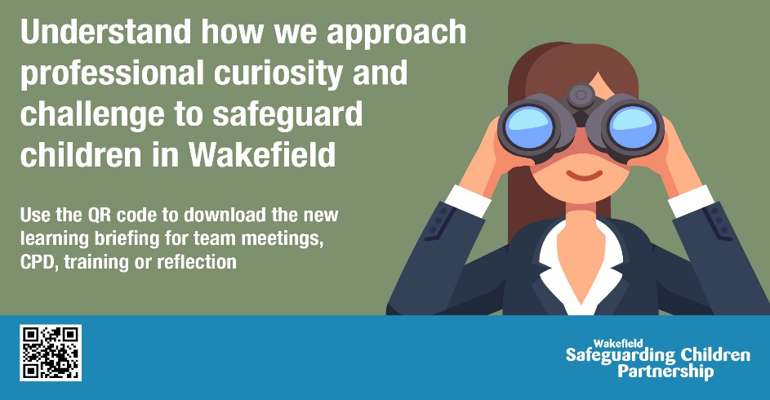
Wakefield Safeguarding Children Partnership (WSCP) is running a district wide campaign on what it means to be professionally curious and challenge in the district from Monday 11th December 2023.
Why are we running a campaign on professional curiosity and challenge?
Learning from safeguarding audits and reviews has told us we need to better embed what it means to be professionally curious and challenging, why it is important, what to listen and look out for, how to check what is being said and what resources can be used to support you in your role.
Throughout this year WSCP has developed a range of new resources for those who work or volunteer with children to use when it comes to professional curiosity and challenge. As such, we want to tell everybody who works or volunteers with children and families in the district about these resources for them to use them in their everyday practice.
The resources and information we’ve developed are:
- Page on the WSCP website – Professional Curiosity & Challenge
- One Minute Guide on Professional Curiosity & Challenge
- Multi-use Learning Briefing on Professional Curiosity & Challenge, including case studies based on safeguarding reviews and audit findings
- Video promotion - https://youtu.be/LumZ9uuqLAo
What is the purpose?
All the resources aim to raise awareness and provide guidance about how to be professionally curious and challenging in the district.
These resources should be used in several ways:
- For personal professional development
- Team meetings / peer support sessions
- Part of single and multi-agency training
- Reflect on as part of supervision
The resources should be used either in their entirety or focus on specific ones as you see fit.
How can you help?
You can help by supporting the campaign, using and sharing all the resources which have been developed.
You can do this by:
- Sharing messages and graphics through internal newsletters, website, and emails to staff about the campaign
- Share key messages and graphics on your service social media accounts and across your networks
- Share and disseminate the video to your networks https://youtu.be/LumZ9uuqLAo
- Use and share the learning briefing on professional curiosity and challenge
- Provide an opportunity for staff to review the resources and supporting guidance available in supervision and team briefings
- Following the WSCP account on X (previously Twitter) and resharing and liking our posts
To help you do this we have provided the following:
- Suggested key messages to promote with social media graphics (please see below)
- 4 x social media graphics to promote with the key messages
- Intranet Banner / Screensaver
- Email signature graphic
Graphics (download by right clicking and clicking ‘save as’)
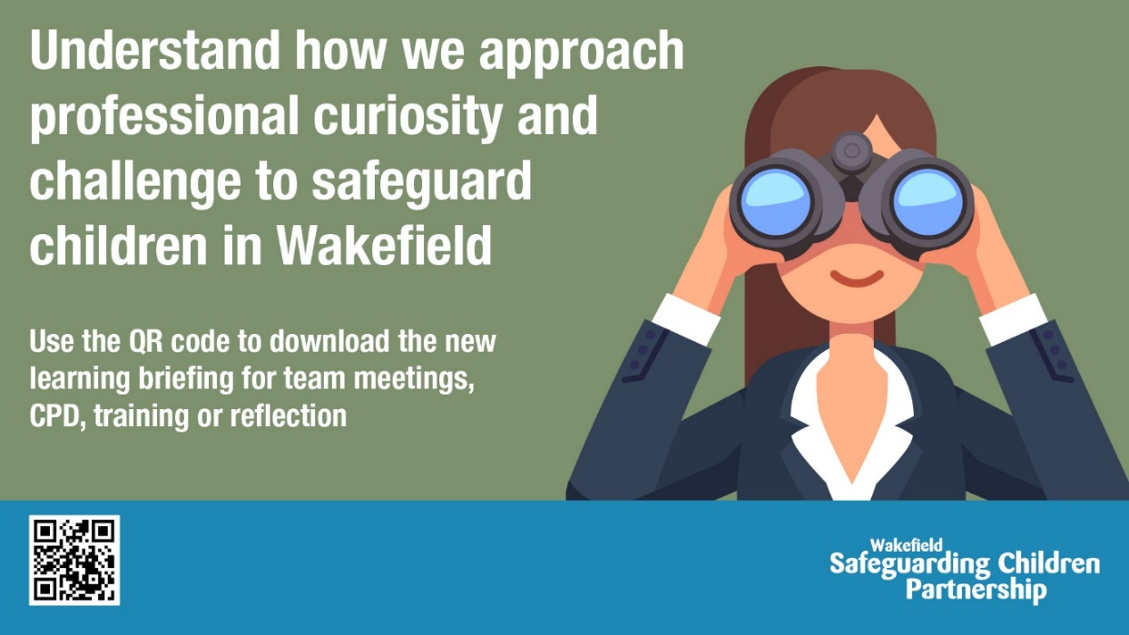
Intranet Banner / Screensaver
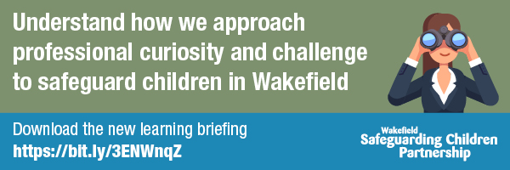
Email signature
Social Media Post #1

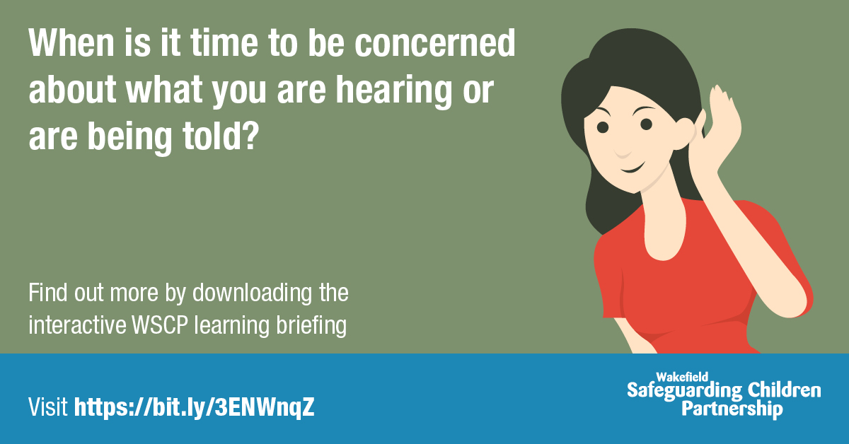
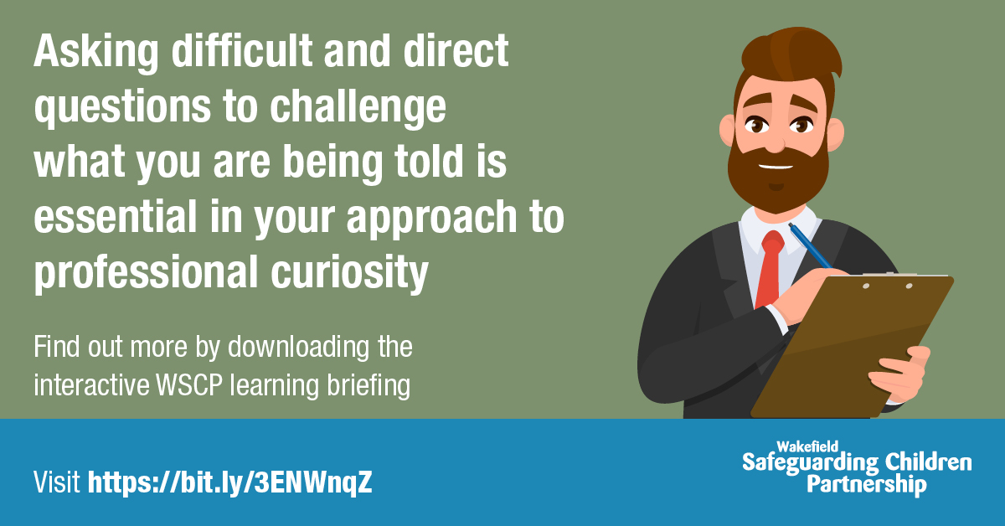
Social Media Post #2

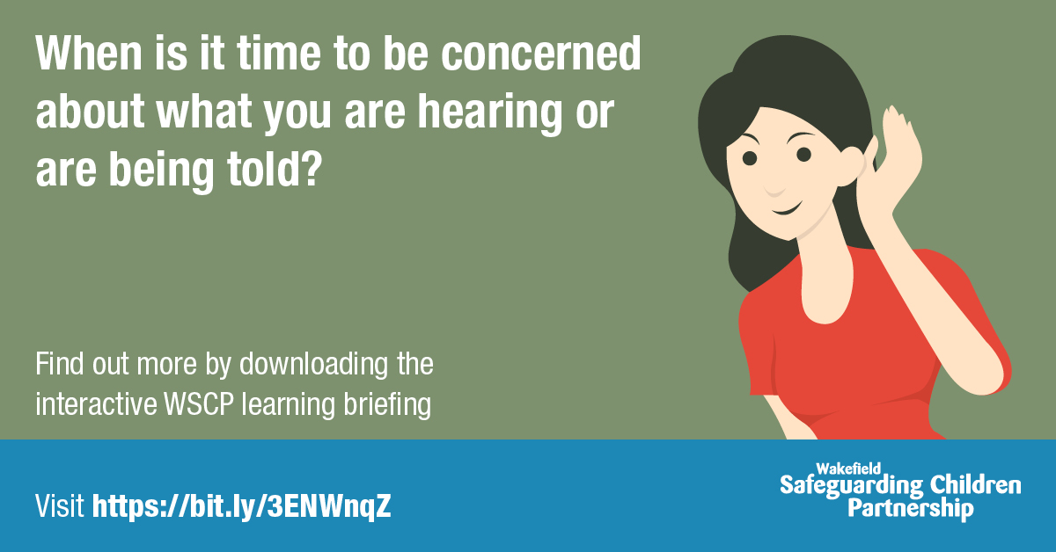
Social Media Post #3

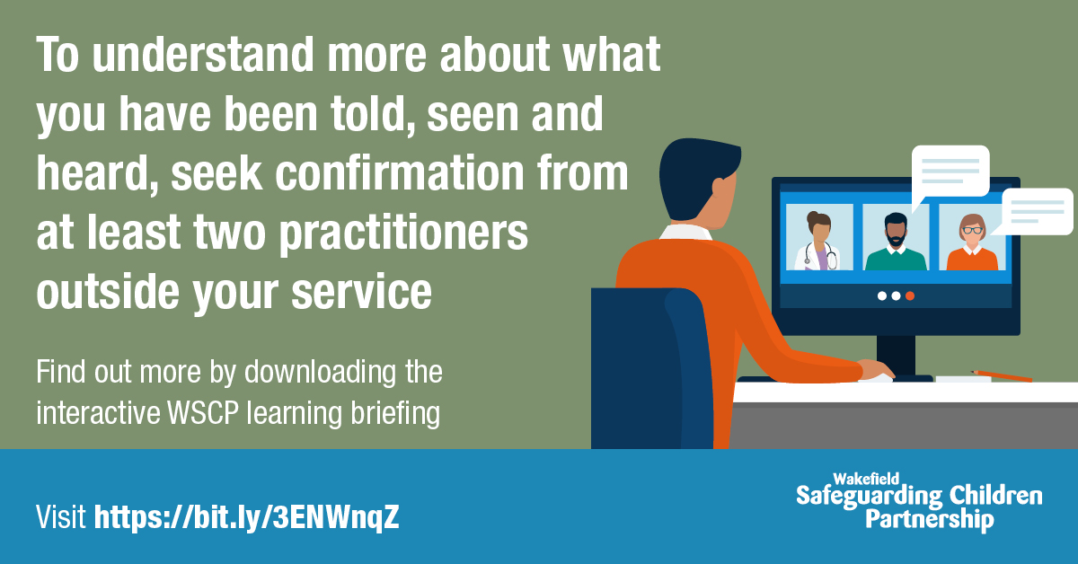
Social Media Post #4
Messages (to use with the above graphics)
1. Have you heard…?
Wakefield SCP have developed a NEW Learning Briefing for Professional Curiosity & Challenge!
Test your own bias, get interactive and take a look ⤵️
Professional Curiosity • Wakefield Safeguarding Children (wakefieldscp.org.uk)
--------------------------
2. A NEW Professional Curiosity & Challenge Learning Briefing has been created for colleagues in the Wakefield District!
The briefing encourages *tick emoji for bullet points*
✅ Respectful nosiness
✅ Challenging your own personal bias
✅ Triangulating information with at least 2 other sources
DOWNLOAD NOW!
Professional Curiosity • Wakefield Safeguarding Children (wakefieldscp.org.uk)
--------------------------
3. ❗ Need some support in having challenging conversations?
To find out about why it is important to be professionally curious, to ensure the right intervention for a family, download the learning briefing here Professional Curiosity • Wakefield Safeguarding Children (wakefieldscp.org.uk)
--------------------------
4. ❓ Making inaccurate assumptions when assessing needs can put the child and family at greater risk
Download our learning briefing here Professional Curiosity • Wakefield Safeguarding Children (wakefieldscp.org.uk)
Resources to download / link to
- Page on the WSCP website – Professional Curiosity & Challenge
- One Minute Guide on Professional Curiosity & Challenge
- Multi-use Learning Briefing on Professional Curiosity & Challenge, including case studies based on safeguarding reviews and audit findings
- Share the WSCP video promotion https://youtu.be/LumZ9uuqLAo
Who to contact
If you have any questions regarding this campaign, please contact WSCP – wscp@wakefield.gov.uk

