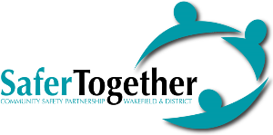

**Operation Encompass – Briefing Session**

**Wednesday 7th December 2022**

**Booking Form**

**Registration at 9am, concluding at 11:30am.**

**Please complete all details below:**

|  |  |
| --- | --- |
| **Name** |  |
| **Job Title** |  |
| **Team / Directorate** |  |
| **Manager’s Name** |  |
| **Organisation** |  |
| **Telephone Number** |  |
| **Email Address** |  |

Please return the completed form to: [DAforum@wakefield.gov.uk](mailto:DAforum@wakefield.gov.uk)

Places for these sessions are limited therefore please book early to avoid disappointment.