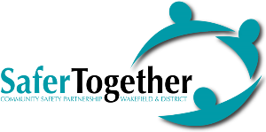

**Supporting the 16 Days of Action and White Ribbon Campaign 2022**

**Operation Encompass – Briefing Session**

**Wednesday 7th December 2022**

An exciting opportunity for *front line practitioners* to learn about Operation Encompass, an early notification initiative which has been running in Wakefield since 2018. The project informs schools and nurseries that a child is experiencing domestic abuse following Police attendance at home, with the aim to ‘make the next day better’.

The free event includes:

* A presentation from founders David Carney - Howarth OBE and Elizabeth Carney - Haworth OBE who will be providing an overview of Operation Encompass from its early development
* A presentation will be delivered which highlights the work undertaken in Wakefield

**Registration at 9am, the event will conclude at 11:30 am.**

**Venue:**

**The Kingswood Suite, Town Hall, Wood Street Wakefield WF1 2HQ.**

**Book your place now using the attached booking form and return to** [**DAforum@wakefield.gov.uk**](mailto:DAforum@wakefield.gov.uk)

**Places are limited and demand is expected to be high.**