A Guide to Signs and Symbols
Extreme Right Wing
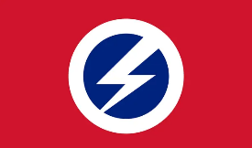  Flash and Circle | Used by the British Union of Fascists in the 1930s, it has since been adopted by other far-right groups and is still in use today.
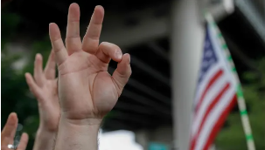  OK Gesture | While in most contexts the sign is harmless, it has been appropriated by some on the far right to signify white power. The perpetrator of the Christchurch mosque attack in New Zealand used it before murdering 51 people in 2019.
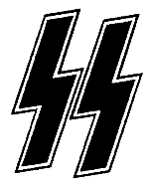  SS Runes | Associated with the Schutzstaffel, the elite paramilitary branch of the Nazi party, the symbol remains popular among neo-Nazis.
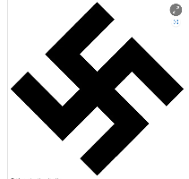  Swastika | The best known of all hate symbols, adopted by the Nazis and still in common use among neo-Nazis, antisemites and white supremacists.
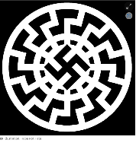  Sonnenrad | An ancient symbol appropriated by the Nazis and used by neo-Nazis today.
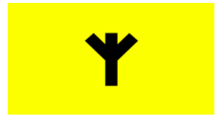  Scottish Dawn | Scottish Dawn was proscribed in September 2017 under a name change order as part of National Action (NA). Described itself as a “patriotic society for the defence of our race and nation, active across Scotland”. Small in numbers, the group attended anti-refugee protests in Scotland, flying flags bearing its group logo. The group used the Algiz/Elhaz rune in its logo. This is a Pagan symbol often worn for protection, either as an item of jewellery or a tattoo (*note context in which this symbol is being used)
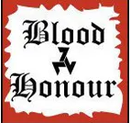  Blood and Honour | The logo for a neo-Nazi music network that started in the UK in 1987 and remains active internationally. Currently not proscribed.
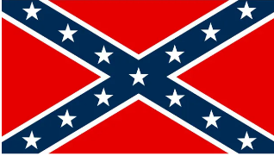  Confederate Flag | The battle flag of the Confederate States of America, the 11 southern states that seceded from the union in 1860-61 mainly because of their support for slavery. While still seen by some as a sign of southern US pride, it is now used by far-right activists internationally.
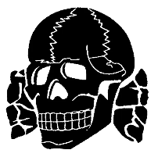  Totenkopt / Combat 18 / C18 | The symbol of Hitler’s SS and used today by antisemites and neo-Nazis who venerate the Holocaust.  Combat 18 is a neo-Nazi organisation that was founded in 1992. It largely drew its membership from white nationalists associated with the Chelsea Headhunters soccer hooligan gang and the neo-nazi record label and political organisation Blood & Honour. It is not a proscribed organisation in the UK, however members are banned from joining the British Prison Service, armed forces and police. The group no longer functions as a centralized organisation however its ideology and brand remain a powerful focus for neo-Nazis worldwide. It has been linked to numerous acts of terrorism worldwide.
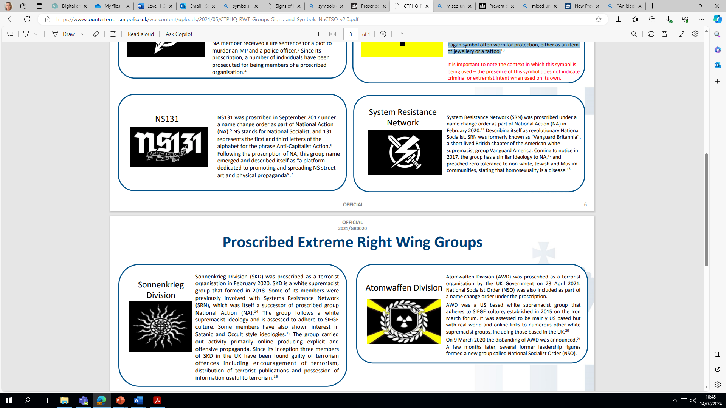  NS131 | NS131 was proscribed in September 2017 under a name change order as part of National Action (NA). NS stands for National Socialist, and 131 represents the first and third letters of the alphabet for the phrase Anti-Capitalist Action. Following the proscription of NA, this group name emerged and described itself as “a platform dedicated to promoting and spreading NS street art and physical propaganda”.
System Resistance Network | System Resistance Network (SRN) was proscribed under a name change order as part of National Action (NA) in February 2020. Describing itself as revolutionary National Socialist, SRN was formerly known as “Vanguard Britannia”, a short lived British chapter of the American white supremacist group Vanguard America. Coming to notice in 2017, the group has a similar ideology to NA,12 and preached zero tolerance to non-white, Jewish and Muslim communities, stating that homosexuality is a disease.
Sonnenkrieg Division | Sonnenkrieg Division (SKD) was proscribed as a terrorist organisation in February 2020. SKD is a white supremacist group that formed in 2018. Some of its members were previously involved with Systems Resistance Network (SRN), which was itself a successor of proscribed group National Action (NA). The group follows a white supremacist ideology and is assessed to adhere to SIEGE culture. Some members have also shown interest in Satanic and Occult style ideologies. The group carried out activity primarily online producing explicit and offensive propaganda. Since its inception three members of SKD in the UK have been found guilty of terrorism offences including encouragement of terrorism, distribution of terrorist publications and possession of information useful to terrorism.
Atomwaffen Division | Atomwaffen Division (AWD) was proscribed as a terrorist organisation by the UK Government on 23 April 2021. National Socialist Order (NSO) was also included as part of a name change order under the proscription. AWD was a US based white supremacist group that adheres to SIEGE culture, established in 2015 on the Iron March forum. It was assessed to be mainly US based but with real world and online links to numerous other white supremacist groups, including those based in the UK.2 On 9 March 2020 the disbanding of AWD was announced. A few months later, several former leadership figures formed a new group called National Socialist Order (NSO).
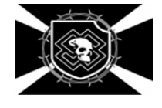  Feuerkrieg Division | Feuerkrieg Division (FKD) was proscribed in July 2020. FKD is a white supremacist group that adheres to SIEGE culture. The group is believed have been formed in Europe led by a 13 year old individual known as the ‘Commander’. FKD is based predominantly online and has created propaganda inciting violence against a number of high profile individuals. One of its members targeted the Chief Constable of West Midlands Police in online postings, following the arrest of one of its members.
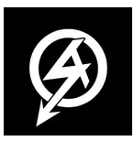  National Action | The logo for National Action, a proscribed neo-Nazi terrorism organisation, is taken from the Sturmabteilung, a paramilitary wing of the Nazi party.
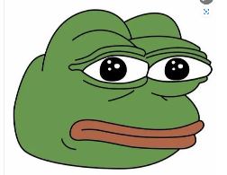  Pepe the Frog | Originally a character in an American comic book series not related to racism or antisemitism, the image has been appropriated by the “alt right” to depict extreme ideas in a supposedly humorous context.
English Defence League (EDL) | English Defence League is a far-right,  Islamophobic organisation and pressure group  in the United Kingdom. It employs street demonstrations as one of its main tactics. It is not a proscribed organisation.
Britain First | Britain First is a far-right, British  fascist political organisation. In November  2017 it was statutorily deregistered as a  party by the Electoral Commission. It is not  proscribed.
Nazi or Hitler Salute | The Nazi or Hitler salute emerged in Nazi  Germany in the 1930’s as a way to pay homage  to Adolf Hitler. It consists of raising an  outstretched right arm with the palm down.  Since World War Two, neo-Nazis and other  white supremacists have continued to use the  salute, making it one of the most common and  recognisable white supremacist hand signs in  the world.
88 Hand Gesture / The number 88 | H is the eighth letter of the alphabet – a simple numerical code for “Heil Hitler”.
18 | Numerical code for Adolf Hitler, A being the first and H the eighth letter of the alphabet.
14 words / 14W | A reference to the “14 words” declaration by white supremacists, which originated in the US in the 1980s: “We must secure the existence of our people and a future for white children.”
1488 | A compound code for the 14 words and “Heil Hitler”.

Islamist
ISIL / ISI / ISIS / DAISh | Islamic State of Iraq and the Levant (ISIL) also known as Dawlat al-‘Iraq al-Islamiyya, Islamic State of Iraq (ISI), Islamic State of Iraq and Syria (ISIS) and Dawlat al Islamiya fi Iraq wa al Sham (DAISh) and the Islmic State in Iraq and Sham is a brutal Sunni Islamist terrorist group active in Iraq and Syria. The group adheres to a global jihadist ideology which is anti-Western and promotes sectarian violence. It is a proscribed terrorist organisation within the UK. ISIL’s flag features a handwritten, rougher version of the ‘shadada’ or Islamic declaration of faith. The white seal is meant to resemble the official seal of the Prophet Muhammad.
Al-Qa’ida (AQ) | Al Qa’ida (AQ) was inspired and led by Usama Bin Laden. Its aims are the expulsion of Western forces from Saudi Arabia, the destruction of Israel and the end of Western influence in the Muslim world. It is a proscribed terrorist organisation within the UK.
The Saved Sect / Saviour Sect / Islam4UK / Islamic Path / London School of Sharia/ Muslims Against Crusades / Al Muhajiroun | The Saved Sect or Saviour Sect (otherwise known as Islam4UK, Islamic Path, London School of Sharia, Muslims Against Crusades and Al Muhajiroun) is an Islamist group which seeks to establish an Islamic Caliphate ruled by Shariah law. It first emerged in the UK in 1996 led by Omar Bakri Muhammed. It is based and operates within the UK. It is a proscribed terrorist organisation within the UK.
Hamas  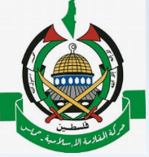 | The flag of Hamas features the shadada on a green background. Hamas is a Sunni Islamist group which seeks to end Israeli occupation in Palestine and establish an Islamic State. It is listed as a proscribed organisation by the UK government.
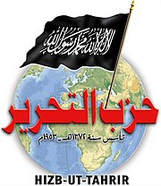  Hizb ut-Tahrir | Hizb ut-Tahrir is an international Sunni Islamist political organisation which was founded in Jerusalem in 1953 by Sheikh Taquiddin an-Nabhani. HQ based in Lebanon. Hizb ut-Tahrir’s stated long-term goal is to unify Muslims worldwide and establish a Caliphate ruled under Islamic (Shari’a) law. Hizb ut-Tahrir Britain is the official branch of Hizb ut-Tahrir in the UK and was established in the UK in the 1980s. It was proscribed on 24th Jan 2024 as the UK government assess that it is currently concerned in terrorism. A number of articles were posted online on Hizb ut-Tahrir’s central media website (and third party websites), attributed to several of Hizb ut-Tahrir’s branches, which celebrated and praised the 7 October 2023 attack by Hamas and associated events.
The ISIS flag | Used as a symbol to show support for Islamic State of Iraq and Syria (ISIS).

NB: (It is important to note that many flags linked to the Muslim faith often bear the ‘shahada’ or Islamic declaration of faith (“There is no god but God, Mu-hammad is the messenger of God”). This includes for example the national flag of Saudi Arabia (below). The presence or absence of this slogan does not determine whether the group it represents is extremist. Green is often used as a background because it is believed that green was Muhammad’s favourite colour.

Northern Ireland Related Terrorism
Irish Republican Army (IRA) | The Irish Republican Army (IRA) (also known as the Provisional Irish Republican Army, Provisional IRA) was an Irish republican paramilitary organisation that sought to end British rule in Northern Ireland and facilitate Irish reunification. It is designated a terrorist organisation in the United Kingdom. It supported the 1998 Good Friday Agreement and in 2005 it disarmed under international supervision.
The Real IRA | The Real Irish Republican Army or Real IRA is a dissident Irish republican paramilitary groups which aims to bring about a united Ireland. It formed in 1997 through dissident members of the Provisional IRA who rejected the Good Friday Agreement. It is the largest and most active of the dissident republican paramilitary groups operating against the security forces. It was responsible for the 1998 Omagh bombing which killed 29 people. It is a proscribed terrorist organisation within the UK.
Ulster Volunteer Force | Ulster Volunteer Force is an Ulster loyalist paramilitary group. Its declared goal was to combat Irish republicanism and maintain Northern Ireland’s status as part of the United Kingdom. It undertook an armed campaign during the period of the Troubles. It declared a ceasefire in 1994 and officially ended its campaign in 2007 although some of its members continue to engage in violence and criminal activities. It is a proscribed terrorist organisation within the UK.
Ulster Defence Association | Ulster Defence Association (also known as the Ulster Freedom Fighters) is an Ulster loyalist paramilitary group in Northern Ireland. It was formed in September 1971. It was extremely active during the period of the Troubles. Its de-clared goal was to defend Ulster Protestant loyalist are-as and combat Irish republicanism. It was proscribed as a terrorist group in August 1992. It declared a ceasefire in 1994 and ended its campaign in 2007 but some of its members have continued to engage in violence.

Left Wing, Anarchist and Single-Issue (LASIT)

0161 Crew  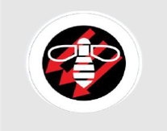 | Anarchist Black Cross | Anarchist Communist Group | Anarchist Federation | Anti-Fascist Network | Campaign Against Arms Trade | Campaign for Nuclear Disarmament  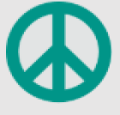 | Class War
Left Hook | Industrial Workers of the World (IWW)  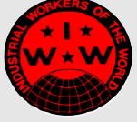 | Palestine Solidarity Campaign (PSC) | Plan C | Revolutionary Communist Group (RCG) | Socialist Party | Socialist Workers Party | Solidarity Federation  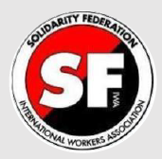
Solstar | Stand Up to Racism | Stop the Arms Fair | Stop the War  Coalition | The Alliance for Workers' Liberty (AWL) | The Communist Party of Britain | Trident  Ploughshares  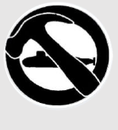 | Unite Against Fascism

All Coppers are Bastards | 99%  Occupy  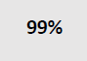 |  | 269  (Anti-Farming) | Anarchist Black Cat  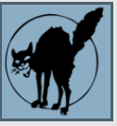 | Anarchist Feminist  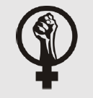 |  | Anarchist Symbol  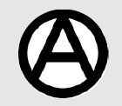 | Anarchist Flag | Anarcho - Syndicalist Flag |  | Environmental Anarchist Flag
Anarcho – Feminist Flag | Anarcho - Queer Flag  (activist term) |  | Anarcho-communist | Anonymous | Anti-Coal |  | Anti-Fascist Symbol | Anti-Fascist Symbol  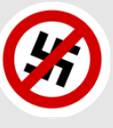 | Anti-Genetically Modified Organisms  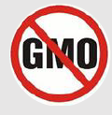 |  | Anti-Nuclear  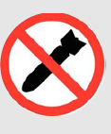
Anti-Nuclear Power  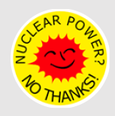 | Critical Mass |  | Good Night White Pride  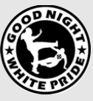 | Direct Action  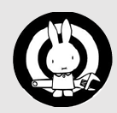 | FITWatch  (Anti Police  Surveillance)  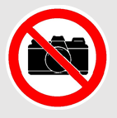 |  | Iron Front (Anti-Fascist Circle  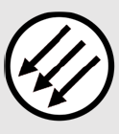 | No Borders | They Shall Not Pass |  | Raised Fist / Socialist  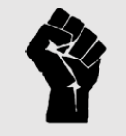
Squatters |  | St Pauli Football Club |  | Skinheads Against Racial Prejudice |  | UK Uncut  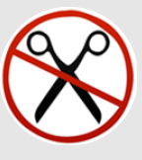 |  | People’s Protection Unit |  | Women’s Protection Unit

