
Briefing:
WSCP Engaging with Men Toolkit Launch

Campaign Title
Engaging Men: See More. Safeguard Better!

Campaign Overview
The Engaging with Men Toolkit has been developed to support practitioners in building confidence, skills, and understanding when working with men across safeguarding contexts.
Research and safeguarding practice reviews have consistently found that fathers, male carers and male partners can be overlooked or insufficiently engaged by services. National learning highlights that men are often "unseen" in assessments and interventions, meaning that both potential risks and protective factors may be missed (Child Safeguarding Practice Review Panel, 2021; NSPCC, 2022).
Whether they are fathers, carers, partners, family members, or individuals requiring support themselves, meaningful engagement with men is essential to achieving positive outcomes for children, families, and adults.
This toolkit provides practical resources to help professionals reflect on their practice, challenge assumptions, and develop effective approaches to engaging men in safeguarding work.
Campaign Objectives
The campaign aims to:
- Raise awareness of the importance of engaging men in safeguarding
- Increase practitioner confidence and competence when working with men
- Promote consistent and inclusive practice across agencies
- Encourage reflection on barriers that may prevent meaningful engagement
- Support professionals to recognise the value men bring to safeguarding and family support networks
This campaign supports the expectations set out in Working Together to Safeguard Children and responds to national safeguarding learning from The Myth of Invisible Men review, which highlighted the need for professionals to identify, assess and engage men more effectively.

Key Messages
Men play varied and significant roles in children’s lives as fathers, non-resident parents, partners, relatives, carers, and community figures. When these men are unseen, poorly understood, or excluded from safeguarding processes, risks can be missed, protective factors overlooked, and opportunities for change lost.
Supporting Messages
- Men play a significant role in the lives of children, families, and adults
- Meaningful engagement helps improve assessment, planning, intervention, and outcomes
- Barriers to engagement can be identified and addressed
- Small changes in practice can have a significant impact
- Practitioners can build confidence through reflection, learning, and the use of practical tools

Who is it designed for?
All practitioners or volunteers needing to refresh or strengthen their knowledge in how to engage with the men in children’s lives.

How you can use the toolkit
✅ Staff bulletin/article
✅ Partner newsletter feature
✅ Social media posts (where appropriate)
✅ Team meeting promotion
✅ Learning and development updates

Resources Available
One Minute Guide
A quick-reference resource highlighting:
- Why engaging men matters
- Common barriers to engagement
- Practical top tips
- Key messages for frontline practitioners
Link: Engaging with Men One Minute Guide - Wakefield Safeguarding Children


Training Sessions: A learning opportunity that:
- Explores the importance of engaging men
- Examines barriers and challenges
- Supports reflective practice
- Provides practical tools and strategies
- Encourages multi-agency discussion and learning
Scan the QR code to access training dates in September and beyond

Toolkit Access: The toolkit link can be found on the WSCP Knowledge Hub webpage.

Wakefield SCP Knowledge Hub - Wakefield Safeguarding Knowledge Hub
QR code to access the toolkit:

Email Signature: A campaign banner for staff to add to their email signatures, helping:
- Raise awareness
- Promote the toolkit
- Increase visibility across partner agencies
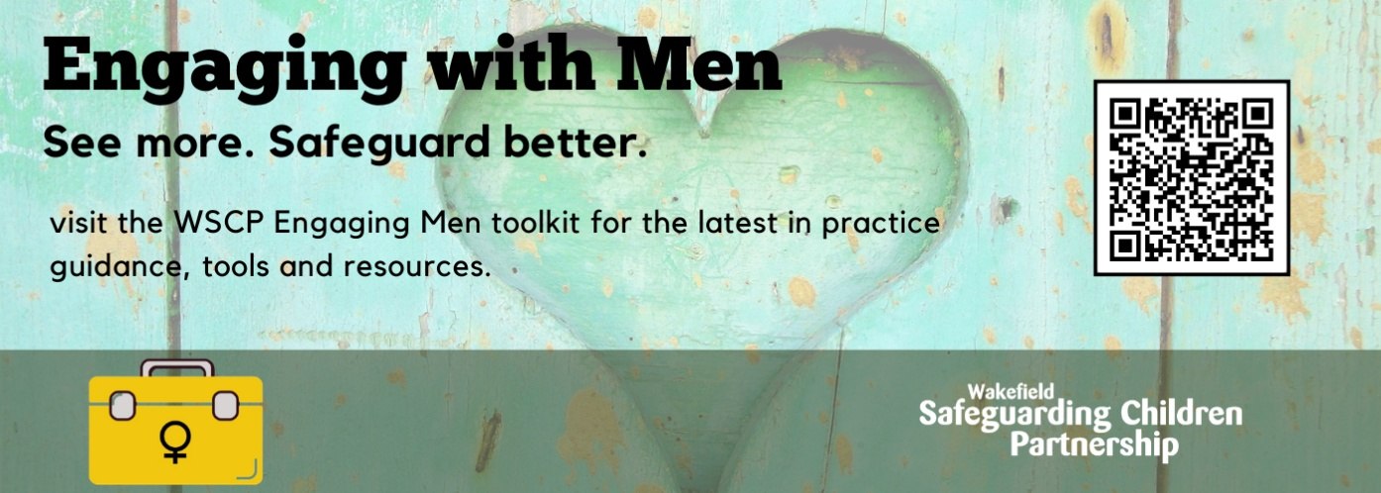

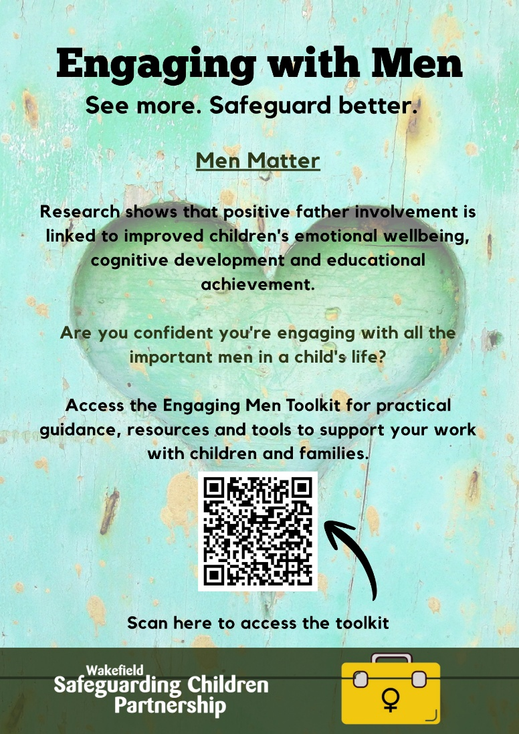
Promotional poster:
A visual awareness resource designed for
- Offices
- Staff rooms
- Learning events
- Team briefings

X Posts: To use on social media platforms

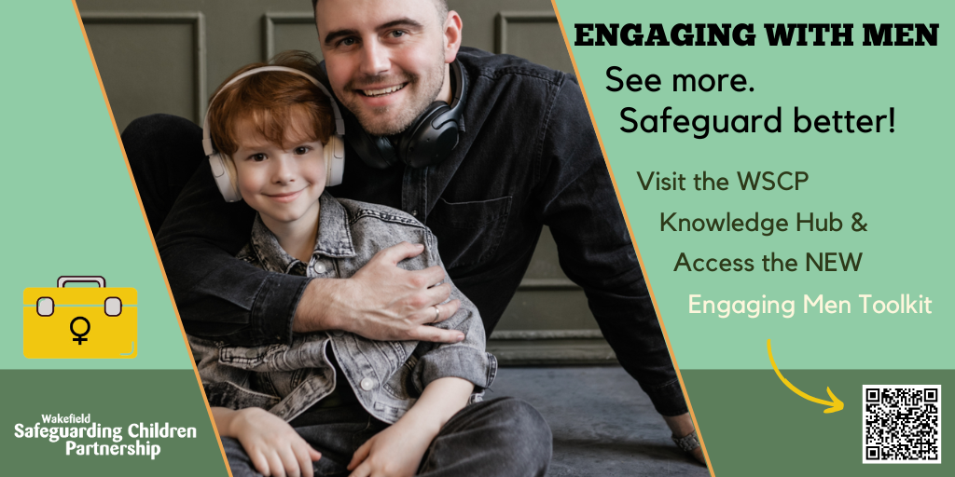

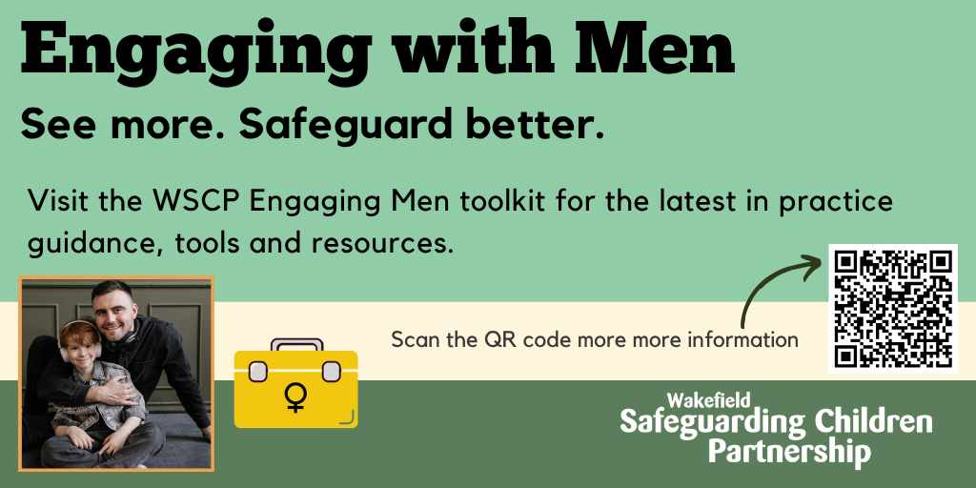

Social Media Messages:
📢 New Engaging with Men Toolkit now available!
Supporting practitioners to build confidence, challenge assumptions and improve safeguarding outcomes through meaningful engagement with men.
🔗 hub.wakefieldscp.org.uk/engaging-with-men/engaging-men/
#EngagingMen #Safeguarding

Are the men in your safeguarding work visible, heard and involved?
Our new toolkit provides practical guidance to support effective engagement with men.
📖 Access here: hub.wakefieldscp.org.uk/engaging-with-men/engaging-men/
#SafeguardingPractice #EngagingMen

