School Attendance is everyone’s business

The following guidance further explains the duties detailed in the above 7 Minute Briefing –
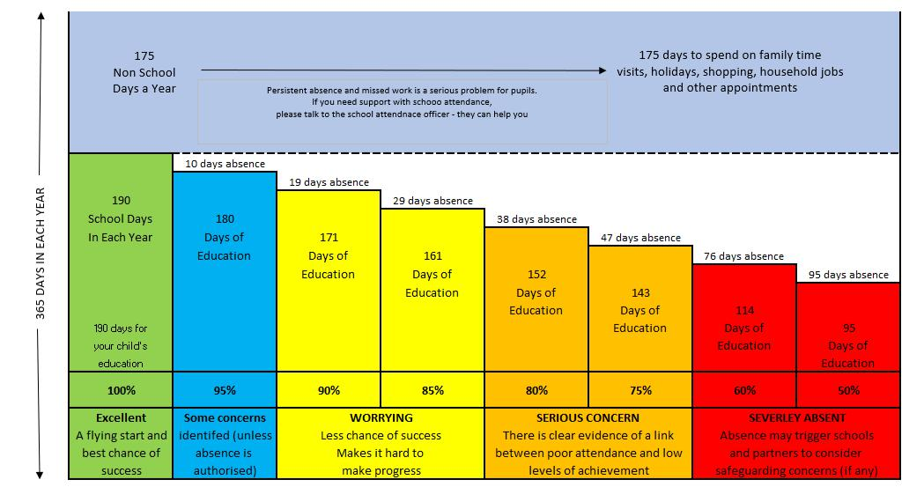

Fig. 1 Graph to demonstrate to parents the reality of school absence

Introduction and context

Attendance is a national priority and after the disruption to learning due to Covid and schools’ closures etc., every school day counts towards positive outcomes for children now and in the future.

The Government has set out expectations for Local Authorities, Schools AND parents in a new document ‘Working Together to Improve School Attendance’:

https://www.gov.uk/government/publications/working-together-to-improve-school-attendance https://www.gov.uk/government/publications/school-attendance/framework-for-securing-full-attendance-actions-for-schools-and-local-authorities

The School’s white paper requires Local Authorities and partners to work more closely with schools where attendance falls below 90% and is identified as a concern. WSCP are sending this clear message: “School attendance is everyone’s business”.

A Serious Case Review (Hakeem BSCB 2017-18/03) https://www.lscpbirmingham.org.uk/images/BSCP/Professionals/Serious_Case_Reviews/BSCB2017-18-03/BSCB_2017-18-03_SCR_Report_-_01.09.22.pdf (Particular paragraphs of note: 5.7 – 5.9 % 5.13 – 5.18)

The report highlighted that ‘there was a lack of understanding [regards threshold for neglect and about the importance of appropriate management of his asthma, alongside the impact of a decline in his home circumstances, and deteriorating school attendance.’

A Social worker assessment provided ‘no evidence of any analysis in relation to multiple neglect factors that were present such as: Educational neglect, including inadequate supervision by his mother, in relation to getting him to school on time, failing to pick him up, which impacted on hisperformance at school, his behaviour and frustration at going from being a ’gifted and talented’ child to getting behind”

Wakefield multi-agency partners are working together to incorporate ‘Educational Neglect’ into Wakefield Continuum of Need and other relevant documents

The threshold for ‘persistent failure’ requires the following to be met over a nine-month period (academic year / 6 half terms):
- Parent failing to attend most school and LA meetings and/or engage with support offered;

- Parent unable to provide substantiated reasons for most absences from school; and

- At least one statutory intervention which fails to improve attendance

i.e. Penalty Notice and/or prosecution (Section 444/4441A)

Educational Threshold for ‘serious impairment of development

- Primary aged children where school attendance is 75% or less over an academic year (three terms), as this halves the possibility of achieving Level 4, the recognised average level for a child at the end of KS2 (2013/14 national research).

- Secondary aged young people where school attendance is 75% or less over an academic year (three terms), as this means the young person is five times less likely to achieve 5 GCSE’s including English and Mathematics, the recognised average level for a young person at the end of KS4 (2013/14 national research).

Process of Support (See 7- minute Briefing)

Early intervention and appropriate support should be offered at the first signs of unauthorised absence. Guidance from the DFE is clear that the prosecution and criminalisation of parents should always be a last resort after all other options to improve school attendance have failed due to non-engagement of the parents and/or the child.
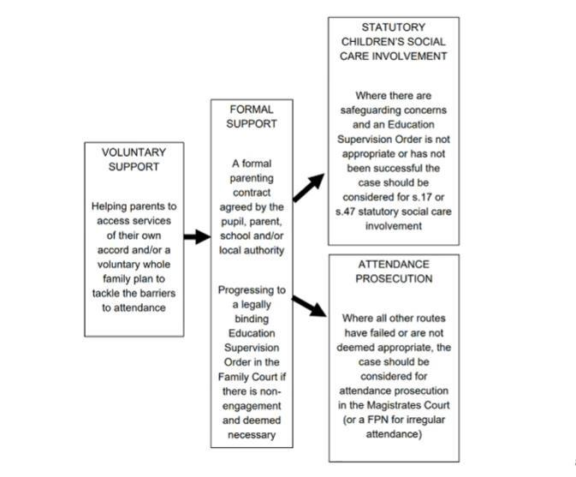

Fig 2.

All partners including social workers, Early Help Practitioners and health professionals etc. are required by the Education White Paper, to act in accordance with the principle that "school attendance (like safeguarding) is everyone's business".

All child related assessments, (including early help and/or sections 17/47) completed by professionals should reference school attendance and the child's right to receive "efficient full time education, appropriate, to their age, aptitude and special educational needs" (1996 education act - s4441).

If assessments are lacking in this respect, we may be missing opportunities to identify potential forms of neglect including, educational neglect. Practitioners from all agencies should:

- Identify and respond to unauthorised, persistent and/or severe absence from school.

- Consider the significance of educational neglect (if applicable) where there is no reasonable / substantiated explanation for absence.

- Demonstrate Professional curiosity in relation to children not in school including those who are Electively home educated and/or not on roll at schools or otherwise

- Challenge parents and carers as to why children are not in / attending school.

- Consider how they / other services might support to resolves the absence from school through the offer of Early Help and as appropriate Multi Agency Early Help.

- Seek advice from the child’s school, or the Education Welfare Service if they are concerned about a child’s attendance.

STATUTORY PATHWAYS

EDUCATION PENALTY NOTICE

- Administered by the Education Welfare Service on behalf of the Local Authority.

- An alternative to prosecution in relation to an unauthorised leave of absence and/or irregular attendance (caused by unauthorised absence).

- Issued where there is a reasonable expectation that this may change; discharges parent’s liability for conviction of an offence by paying under the Education (Penalty Notices) (England) Regulations 2007.

PROSECUTION – ABSOLUTE / AGGRAVATED OFFENCE (Magistrates Court)

Prosecution of a parent, under Section 444(1) of the Education Act 1996, for irregular attendance of child with unauthorised absence; this is a strict liability offence with limited defences.

Prosecution of a parent, under Section 444(1A) of the Education Act 1996, for irregular attendance of child with unauthorised absence; parent knows about irregular attendance and fails without reasonable justification to change this, potential of custodial sentence.

SCHOOL ATTENDANCE ORDER (Magistrates Court if not resolved)

Require parent(s), under Education Act 1996, to register a child of compulsory school age at a named school when not receiving a suitable education.

Above might apply to children who are electively home educated or not on a school roll.

EDUCATION SUPERVISION ORDER (Family Court)

12month Order under Section 36 of the Children Act 1989 “the child is not being suitably educated”:

Before instituting proceedings, the LA must consult with social services where the child resides. The LA / social care may decide to
- provide support to the child and family

- Accommodate the child and/or

- Apply for an education supervision order (1 year - may be extended up to 3 years). It is the duty of the supervisor* to advise, assist and befriend plus give direction to the child and his parents in such a way as to ensure the child is properly educated and receives “efficient full time education at school or otherwise”.

(*lead professionals from the local authority and/or relevant partner agencies including (but not limited to) Education Welfare Service / Social Worker / Multi agency Early Help worker / Youth Offending Officer etc)

Breach of the education supervision order is likely to lead to prosecution of the parent at the higher threshold under section 4441A (fine up to £2500 and/or a period in custody of up to 12 weeks).

For further information please contact ews@wakefield.gov.uk

