INFORMATION/FRONT SHEET

Full Name:  Gender: |  |  | DOB:  Ethnicity: |  |  |  | Class/Form: |  |  | Additional needs:
Home Address: |  |  |  |  |  |  | Telephone:  E mail:
Status of file and dates:

OPEN
CLOSED
TRANSFER
Any other child protection records held in school relating to this child or a child closely connected to him/her?
YES/NO WHO?

Members of household
Name | Relationship to child |  |  |  | DOB/Age |  |  |  | Tel No
Significant Others (relatives, carers, friends, child minders, etc.)

Name | Relationship to child |  |  |  |  |  | Address |  |  |  | Tel No
Other Agency Involvement

Name of officer/person |  | Role and Agency |  | Status of Child i.e. CAF/CIN/CP/LAC |  |  |  | Tel No |  |  | Date

Chronology

Sheet Number:

Complete for all incidents of concern including where a ‘logging the concern’ sheet has not been completed. If one has been completed then add a note to this chronology to cross reference (significant information may also be added).

Name:

DOB: |  | Class/Form:
Date | Information/Details of concerns or contact |  | Print Name and Signature

Logging a concern about a child’s safety and welfare
Part 1 (for use by any staff)
Pupil’s Name: | Date of Birth: Class:
Date and Time of Incident: | Date and Time (of writing):
Name:
…………………………………………………………….. ……………………………………………………………. Print Signature

Job Title:
Record the following factually: What are you worried about? Who? What (if recording a verbal disclosure by a child use their words)? Where? When (date and time of incident)? Any witnesses?

What is the pupil’s account/perspective?

Professional opinion where relevant.

Any other relevant information (distinguish between fact and opinion). Previous concerns etc.

What needs to happen? Note actions, including names of anyone to whom your information was passed and when.

Check to make sure your report is clear to someone else reading it.
Please pass this form to your Designated Safeguarding Lead.
Part 2 (for use by DSL)
Time and date information received, and from whom.

Any advice sought – if required (date, time, name, role, organisation and advice given).

Action taken (referral to children’s social care/monitoring advice given to appropriate staff/CAF etc.) with reasons.

Note time, date, names, who information shared with and when etc.

Parent’s informed? Y/N and reasons.

Outcome

Record names of individuals/agencies who have given information regarding outcome of any referral (if made).
Where can additional information regarding child/incident be found (e.g. pupil file, serious incident book)?
Should a concern/ confidential file be commenced if there is not already one? Why?
Signed
Printed Name

Logging concerns/information shared by others external to the school (Pass to Designated Person)
Pupil’s Name: |  | Date of Birth:  Class/form:
Date and Time of Incident: |  | Date and Time of receipt of information:  Via letter / telephone etc.
Recipient (and role) of information:
Name of caller/provider of information:
Organisation/agency/role:
Contact details (telephone number/address/e-mail)
Relationship to the child/family:
Information received:
Actions/Recommendations for the school:
Outcome:
Name:
Signature:
Date and time completed:
Counter Signed by Designated Safeguarding Lead
Name:
Date and time:

Body Map Guidance for Schools

Body Maps should be used to document and illustrate visible signs of harm and physical injuries.

Always use a black pen (never a pencil) and do not use correction fluid or any other eraser.

Do not remove clothing for the purpose of the examination unless the injury site is freely available because of treatment.
*At no time should an individual teacher/member of staff or school take photographic evidence of any injuries or marks to a child’s person, the body map below should be used. Any concerns should be reported and recorded without delay to the appropriate safeguarding services, e.g. Social Care direct or child’s social worker if already an open case to social care.

When you notice an injury to a child, try to record the following information in respect of each mark identified e.g. red areas, swelling, bruising, cuts, lacerations and wounds, scalds and burns:

- Exact site of injury on the body, e.g. upper outer arm/left cheek.
- Size of injury - in appropriate centimetres or inches.
- Approximate shape of injury, e.g. round/square or straight line.
- Colour of injury - if more than one colour, say so.
- Is the skin broken?
- Is there any swelling at the site of the injury, or elsewhere?
- Is there a scab/any blistering/any bleeding?
- Is the injury clean or is there grit/fluff etc.?
- Is mobility restricted as a result of the injury?
- Does the site of the injury feel hot?
- Does the child feel hot?
- Does the child feel pain?
- Has the child’s body shape changed/are they holding themselves differently?

Importantly the date and time of the recording must be stated as well as the name and designation of the person making the record. Add any further comments as required.

Ensure First Aid is provided where required and record

A copy of the body map should be kept on the child’s concern/confidential file.

BODYMAP
(This must be completed at time of observation)

Name of Pupil: |  |  | Date of Birth:
Name of Staff: |  |  | Job title:
Date and time of observation:

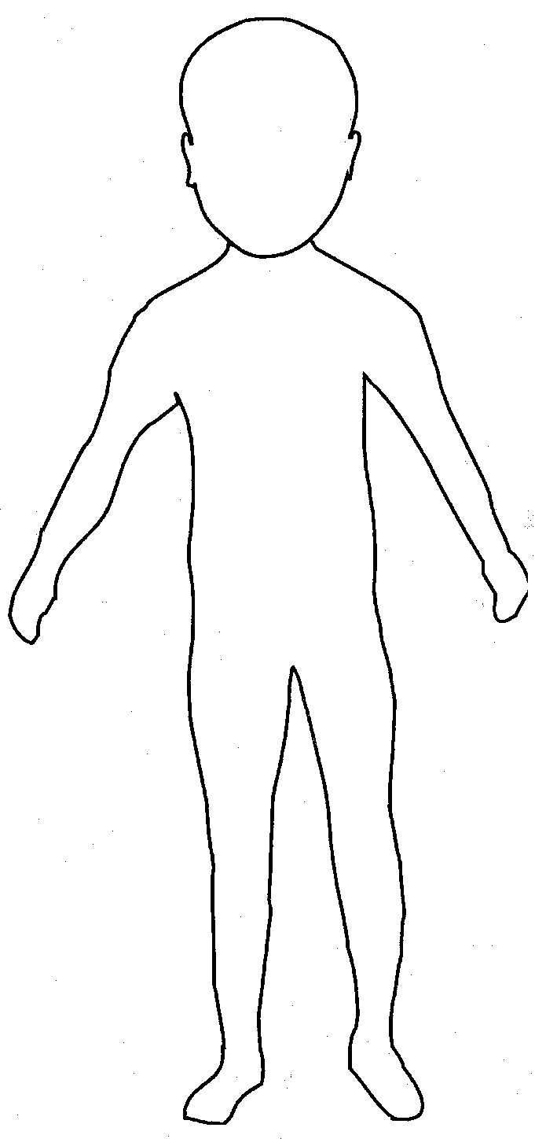 | 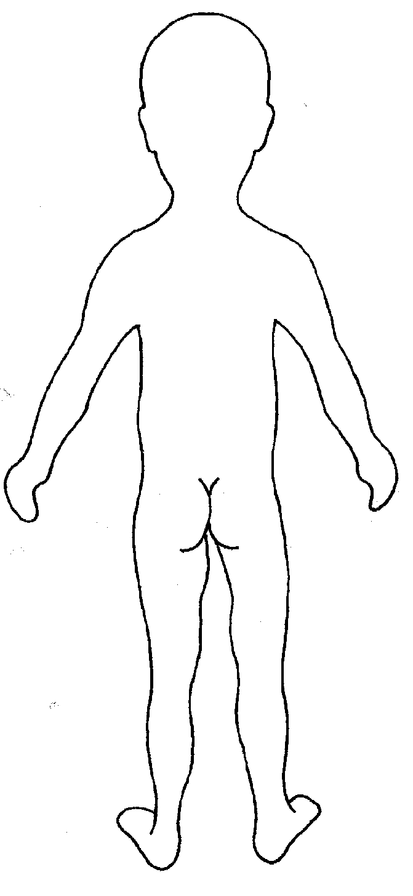

Name of pupil: |  |  | Date and time of observation:
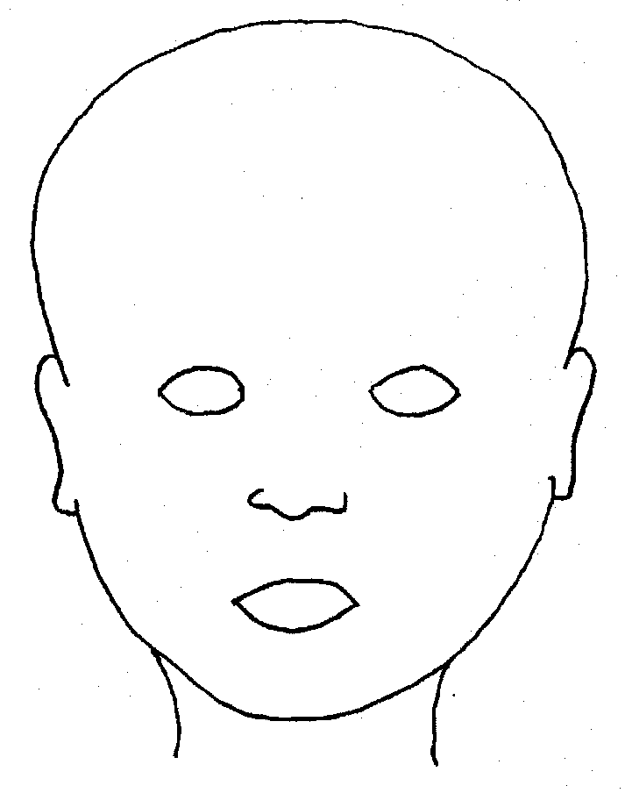
FRONT |  | BACK
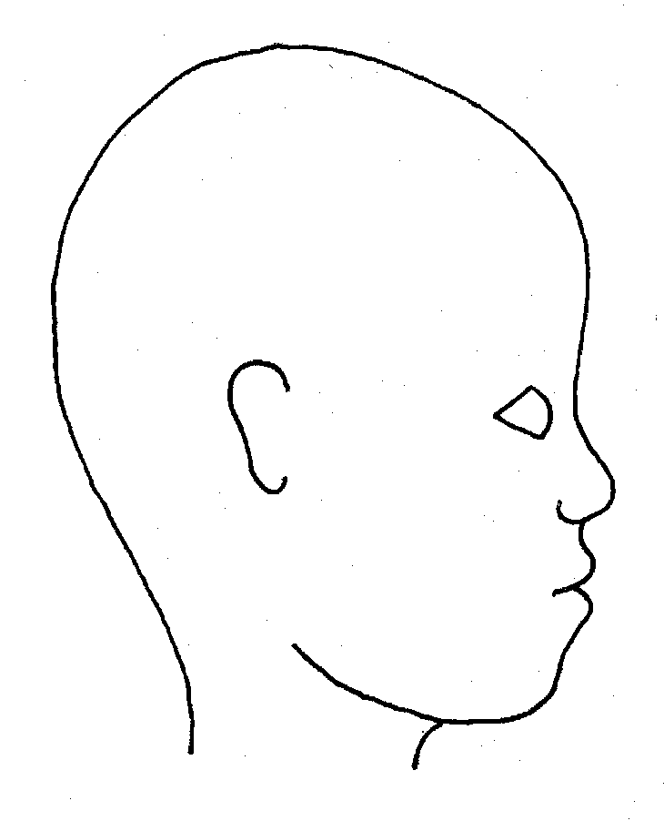 |  | 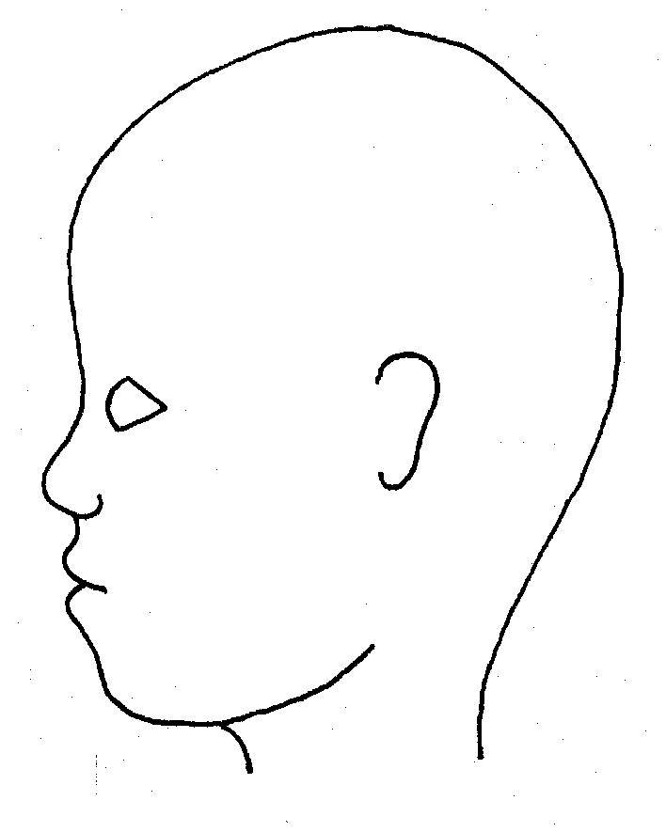
RIGHT |  | LEFT

Name of pupil: |  |  |  |  |  |  | Date and time of observation:
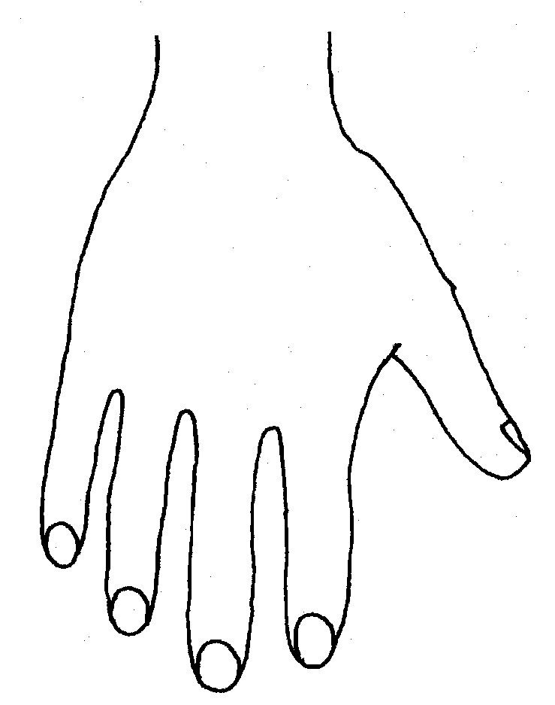 |  |  |  |  |  | 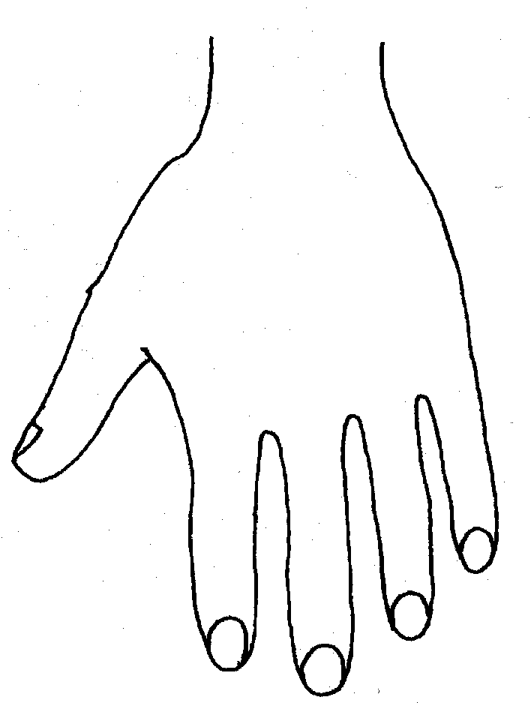
R |  |  |  |  |  | L
BACK
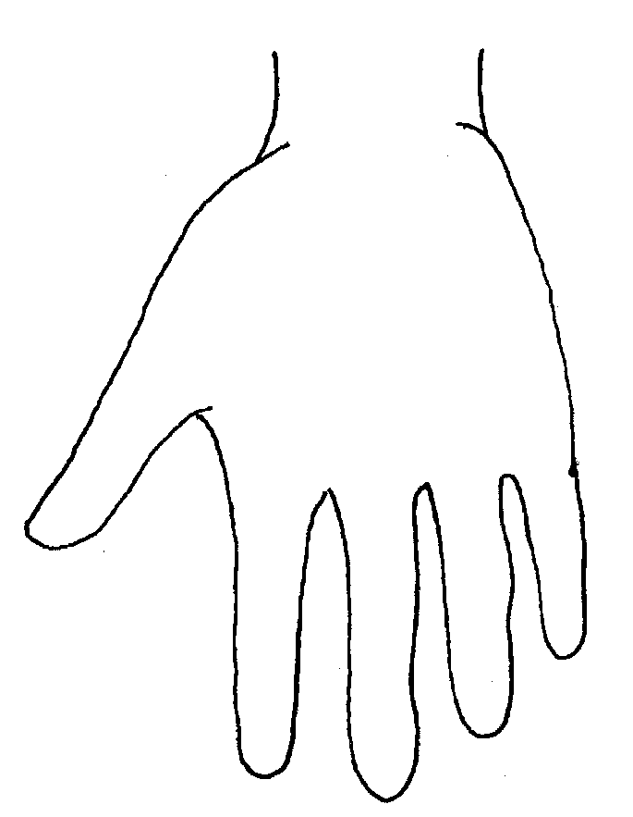 |  |  |  |  |  | 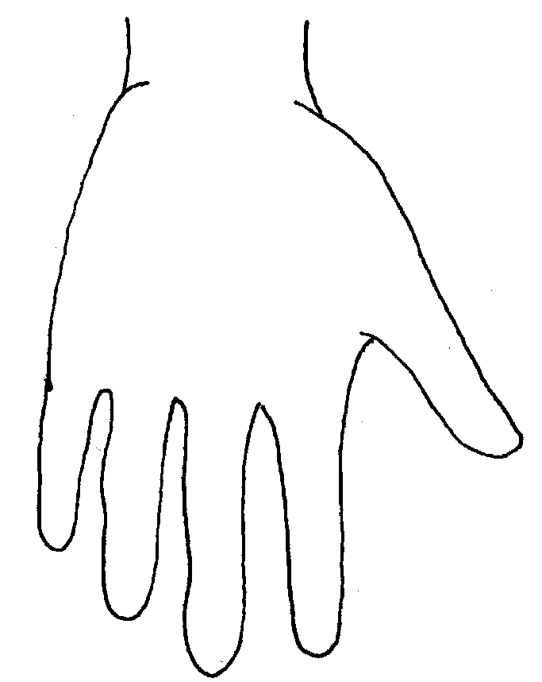
Name of Pupil: |  |  |  |  |  |  | Date and time of observation:
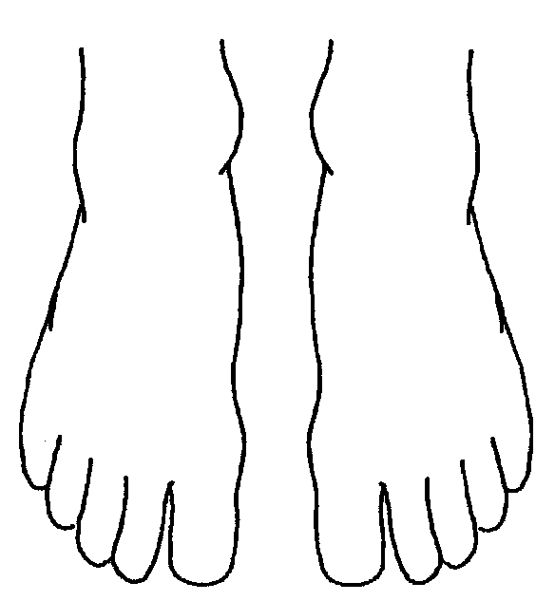 |  |  |  |  | 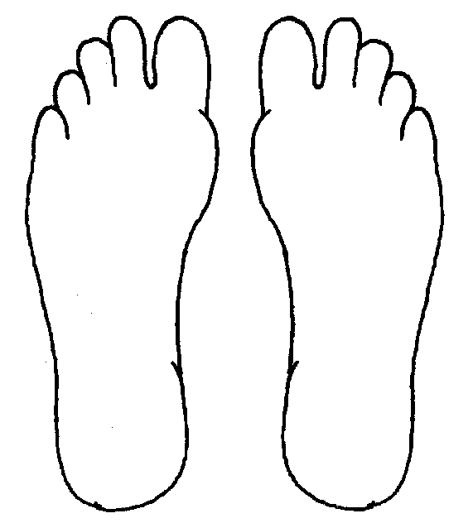
R | TOP |  |  | L | R |  |  | BOTTOM |  |  |  | L
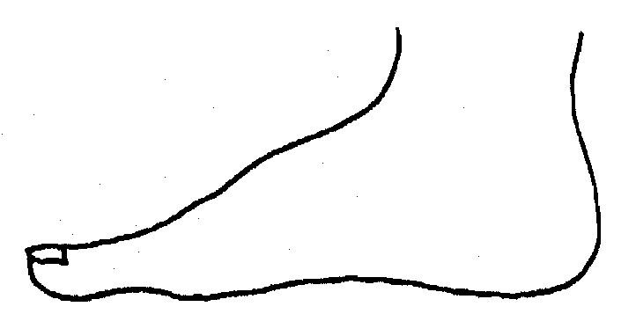
R |  |  |  |  | L
INNER
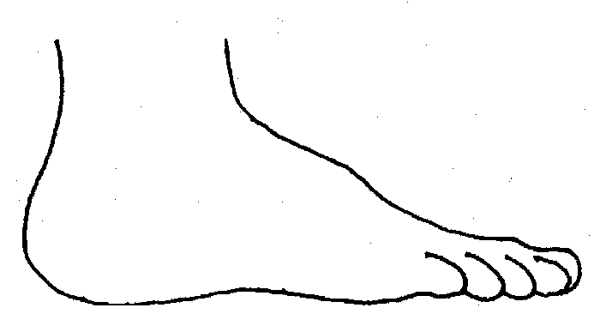 |  |  |  |  | 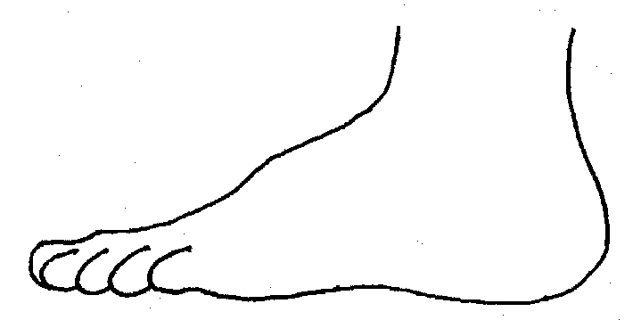
R |  |  |  |  | L
OUTER
Printed Name, Signature and Job title of staff:

Blank template
Name of Child | DOB Class/form | Home Address | Parents/carer contact details | Name of Social worker and contact details | Other Agencies | Type of Plan  LAC  CP  CIN  CAF | Dates of: Conference,Reviews and Meetings

