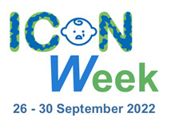

COMMUNICATIONS TOOLKIT

www.iconcope.org/iconweek2022

#ICONWeek2022

V1.2
Table of Contents
Background 3
About ICON 3
Template press release 4
Website, Intranet and newsletter copy 6
Webinar programme 7
Social media calandar 9
Artwork 10
Microsoft Teams backgrounds 10
Email footer 11
Social media graphics 11

Background

About ICON

The idea for the ICON programme and the different interventions within it was conceived by Dr Suzanne Smith PhD following a Winston Churchill Memorial Trust Travel Fellowship to the USA and Canada in 2016 which included the study of effective interventions and research into the prevention of Abusive Head Trauma (AHT). Research suggests that some lose control when a baby’s crying becomes too much. Some go on to shake a baby with devastating consequences.

Suzanne found that the most effective evidence-based programmes studied provide a simple message that supports parents/caregivers to cope with infant crying. Apart from preventing AHT, most people who have ever cared for a baby appreciate some advice about how to comfort a crying baby and how to cope when it goes on for a long time.

ICON is all about helping people who care for babies to cope with crying.

ICON stands for ….

I Infant crying is normal
C Comforting methods can help
O It’s OK to walk away
N Never, ever shake a baby

Speak to someone if you need support such as your family, friends, midwife, GP or health visitor.

More information and a wealth of resources are available on the ICON Cope website – www.iconcope.org

press release (please localise)

ICON Week 2022: Raising awareness of infant crying and how to cope

“Babies cry, you can cope!” that’s the message from NHS, local authorities, and healthcare organisations from across the country who have come together this September to promote lifesaving messages to parents.

Research suggests that some parents and caregivers can lose control when a baby’s crying becomes too much. Some go on to shake a baby with devastating consequences.

Abusive Head Trauma (AHT) causes catastrophic brain injuries, which can lead to death, or significant long-term health and learning disabilities.

ICON is a programme adopted by health and social care organisations in the UK to provide information about infant crying, including how to cope, support parents/carers, reduce stress and prevent abusive head trauma in babies.

The second annual ICON week, spanning from 26 September – 30 September 2022, aims to raise awareness of infant crying and how to cope in a bid to support parents/carers and prevent serious injury, illness and even death of young babies a result of these incidents.

The evidence-based programme consists of a series of brief interventions that reinforce the simple message making up the ICON acronym:

I Infant crying is normal and it will stop
C Comport methods can sometimes soothe the baby and the crying will stop
O It’s OK to walk away for a few minutes if you have checked the baby is safe and the crying is getting to you
N Never ever shake or hurt a baby

Most babies start to cry more frequently from two weeks of age, with a peak usually being seen around 6-8 weeks. Organisations coming together from 26 September – 30 September, aim to spread the messages to help normalise infant crying and share coping techniques to help parents to deal with the stress it can cause.

Nurse, health visitor and founder of ICON, Dr Suzanne Smith, said: “Abusive head trauma can occur in any environment when a parent or carer is on the edge due to infant crying.

“The pressure that families are under is only being exacerbated by added pressures of the cost-of-living increase and the impact can be far-reaching and have devastating consequences.

“ICON is about sharing messages of support and advice to parents and carers who might be struggling to cope. We want to normalise the fact that babies do cry and some aren’t easily soothed and we want to share information far and wide about what to do in these situations and how to stay calm.

“By sharing these vitally important messages and coping techniques to carers, we are working towards reducing the risk of harm to babies and protecting them from AHT which is utterly preventable.

“Anyone who needs help and is struggling to cope, don’t continue to struggle. Help is available from your midwife, health visitor, GP or go online and there are more resources on our ICON website.”

For more information visit www.iconcope.org/iconweek2022.

ENDS

Website, Intranet and newsletter Copy

ICON Week 2022

The second annual ICON week (26 to 30 September 2022) is here to raise awareness of infant crying and how to cope to support parents/carers and prevent serious injury, illness and even death of young babies as a result of Abusive Head Trauma that happens when someone shakes a baby.

ICON is a programme adopted by health and social care organisations in the UK to provide information about infant crying, including how to cope, support parents/carers, and reduce stress.

This year’s ICON Week is focussing on sharing ideas and best practice. More than 15 webinars are taking place throughout the week with speakers from the military, police, primary care, parent ambassadors, health visitors, and the education section. These are open to everyone, and the access details are available at www.iconcope.org/iconweek2022

Webinar programme

Monday 26 September
10:00-11:00  11:30-12:00 | Sue Anslow – ICON Programme Manager welcome to ICON Week  Dr Suzanne Smith Founder of ICON – Introduction and background to ICON  Jill Broadhurst Senior Family Support Worker- ICON in the Early Years’ service
14:00-15:00 | Jill Broadhurst Senior Family Support Worker- ICON in the Early Years’ service
Tuesday 27 September
09:30-10:00  10:30-11:00 | Jenny Roddy Public Health Specialist Midwife, Leeds Teaching Hospital NHS Trust - The progress and embedment of the ICON within maternity service in Leeds  Sara Waters Health Visitor Team Leader – Health Visitor Delivery of ICON in Manchester
13:00-13:30  16:00-16:30 | Caroline Campbell Development Health Visitor and colleagues- Health Visitor Delivery of ICON in Staffordshire  Claire Bainbridge Lead Midwife for Safeguarding- ICON within Safeguarding and next steps in North Cumbria
Wednesday 28 September
10:00-10:30 | GPs - Working with GPs as commissioners to embed ICON
13:30-14:00  14.15-14.45 | GPs - what do you need to know as a primary care clinician?  Dr Jamie Carter Consultant Paediatrician -AHT and Legal Complexities
Thursday 29 September
10:30-11:00  11.30-12 | Dr Giles Haythornthwaite Consultant Paediatrician: Why the Major trauma network supports ICON  Gaynor Lovatt Team Leader Burnley Neonatal Unit - ICON in the Neonatal Unit
15:30-16:00 | Beth Williams PSHE Lead Fleetwood High School – Delivering the ICON Message in High School
Friday 30 September
10:00-10:30  10:45-11:15  11:30-12:00 | Andrew Ryan Detective Superintendent Merseyside Police  Clare Henderson/ICON in the Military – Health Visitor from Cyprus gives an overview  Parent Ambassadors talk about ICON
13:00-13:30  14:00-14:30  15:00 | Clare Henderson/ ICON in the Military – Health Visitor from Cyprus gives an overview  Andrew Ryan Detective Superintendent Merseyside police  Final thought and close from Dr Suzanne Smith

All webinars are on Microsoft Teams and available at this link bit.ly/iconweek2022

Full details are available on our website: www.iconcope.org/iconweek2022

Social media CALENDAR

MONDAY 26 September | It's finally here! #ICONweek2022.  Our exciting week of webinars includes speakers from the military, police, GPs, parent ambassadors, health visitors, and the education section.  Visit www.iconcope.org/iconweek2022 for more details  #ICONcope | 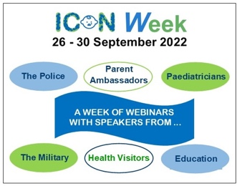
TUESDAY 27 September | If you have a baby that cries a lot, it can be exhausting and lonely. You are not alone.  Crying is normal. It is not your fault. It's ok to take a time out when you feel overwhelmed.  Keep baby safe, keep yourself safe.  #ICONcope  #ICONweek2022 | 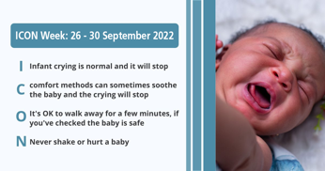
WEDNESDAY 28 September | Abusive head trauma can occur in any environment when a parent or carer is on the edge due to infant crying.  Make sure anyone looking after your child knows the ICON principles. https://iconcope.org/parentsadvice/  #ICONweek2022 #ICONcope | 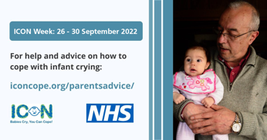
THURSDAY 29 September | There are lots of things you can do to help soothe your baby. Check out our top 5 tips to help with infant crying. The main thing to remember is to stay calm and never hurt or shake your baby. #ICONcope #ICONweek2022 | 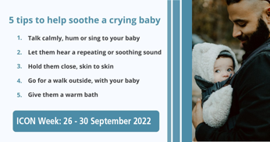
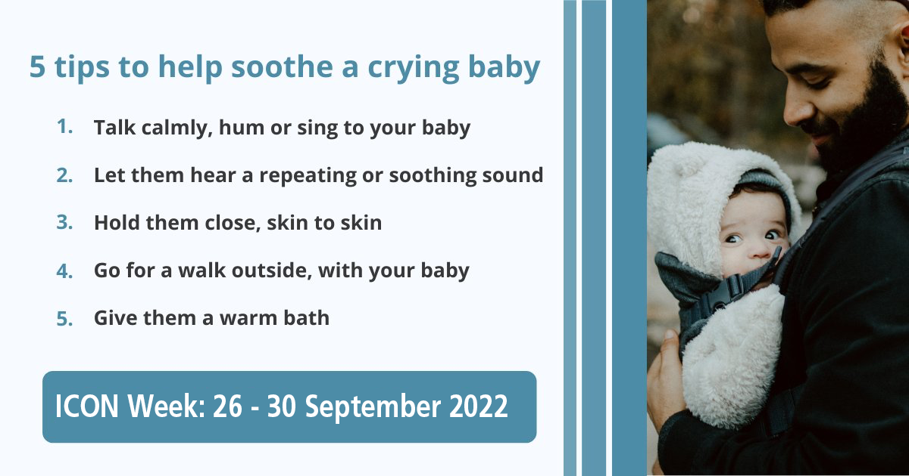FRIDAY 30 September | It’s tough when your baby won’t stop crying. You may worry something is wrong with your child, that you’ll lose your cool or that your parenting skills aren’t up to the job. But you can handle it!  * Take a break  * Ask for help  NEVER SHAKE YOUR BABY!  #ICONcope #ICONweek2022 | 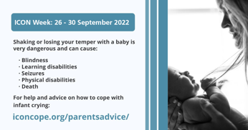

Artwork and graphics

Microsoft Teams backgrounds

Version 1
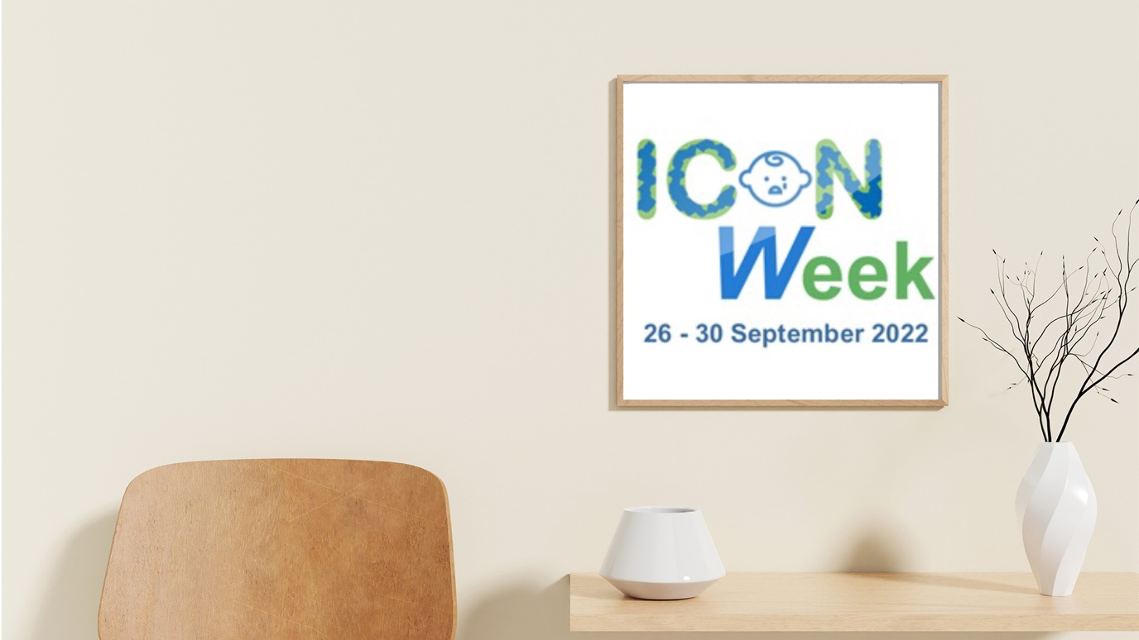
Version 2
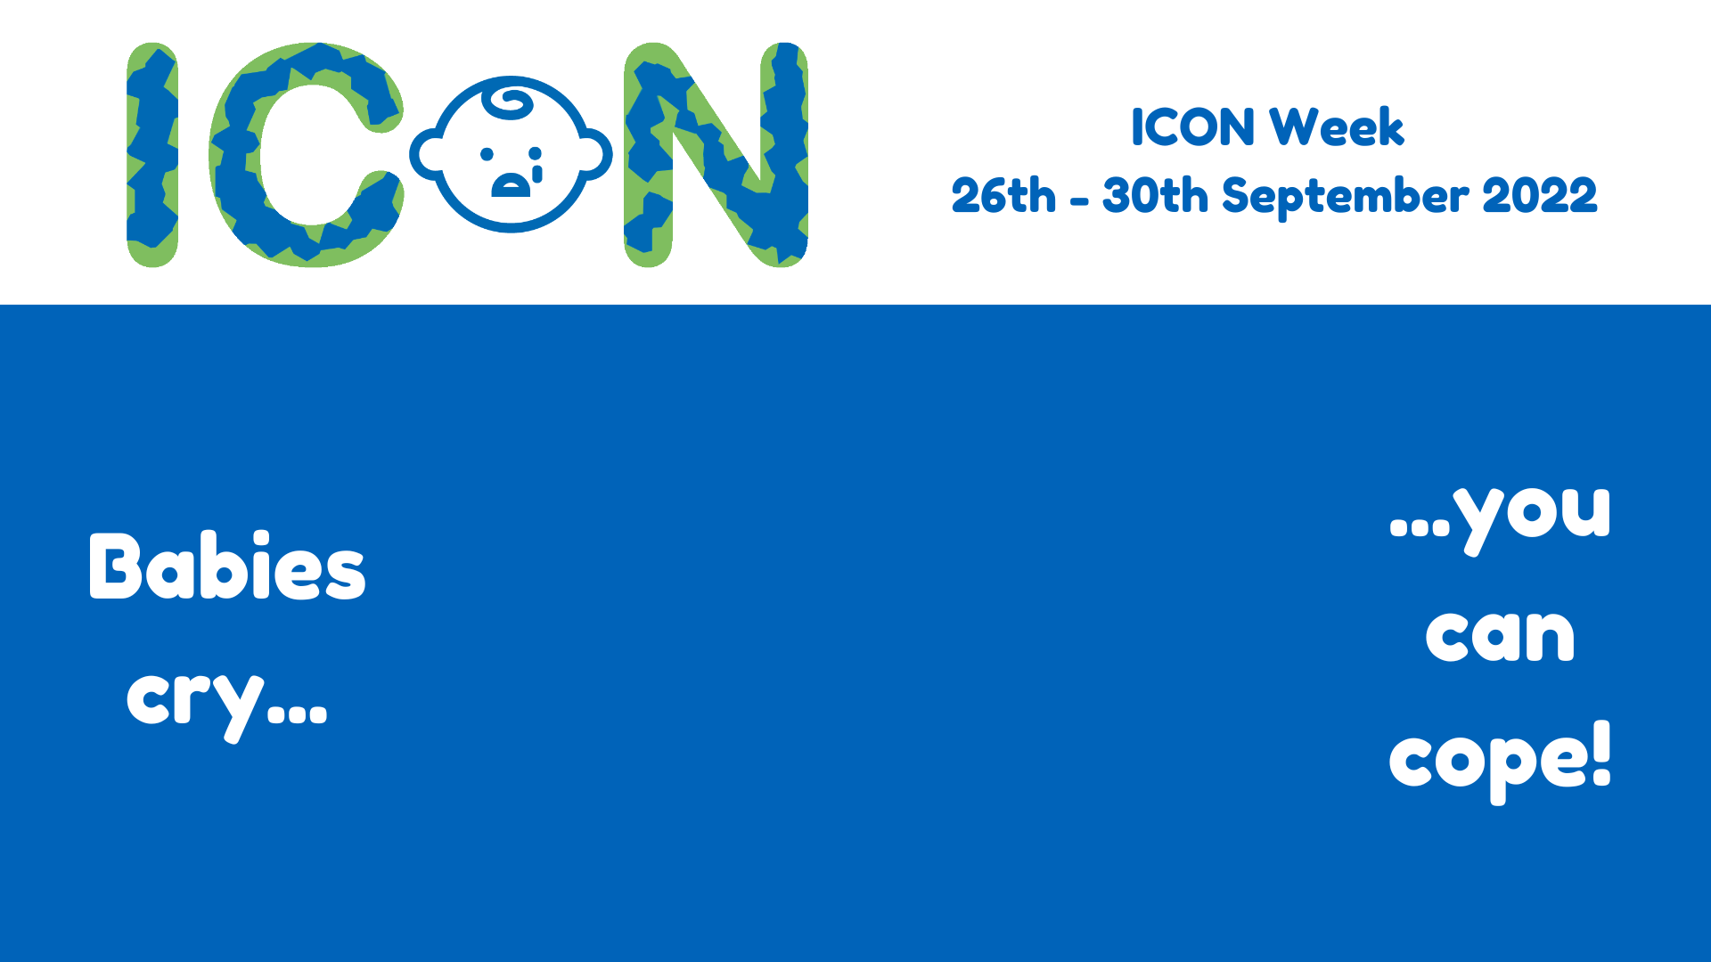

Email footer

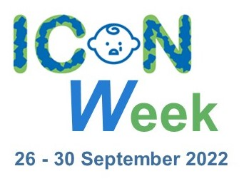

Social media graphics

Graphic 1
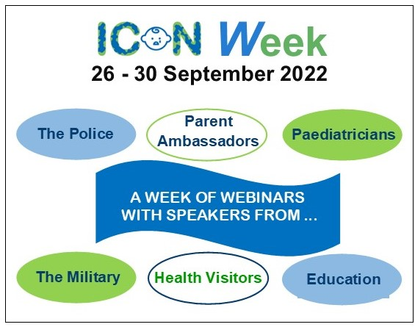

Graphic 2
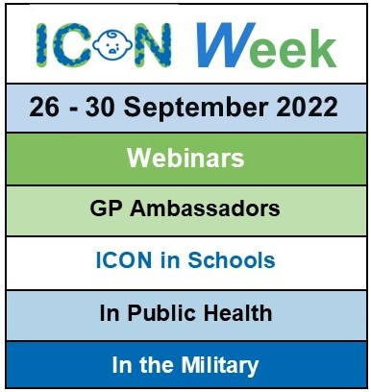

Graphic 3
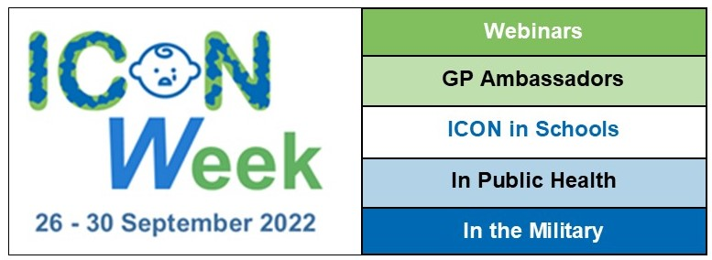

Graphic 4
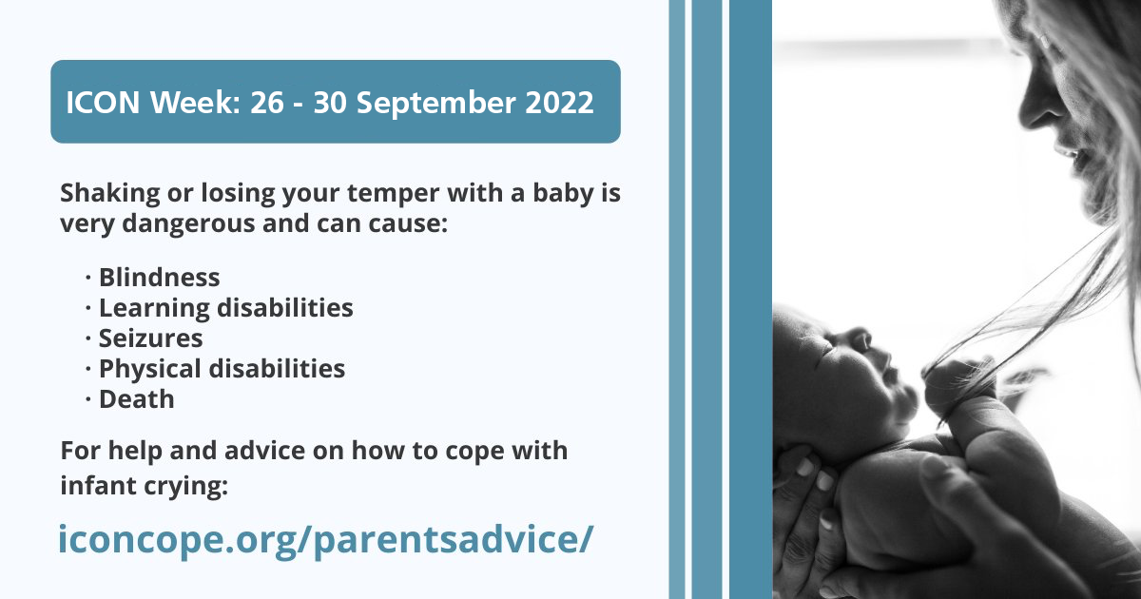

Graphic 5

Graphic 6
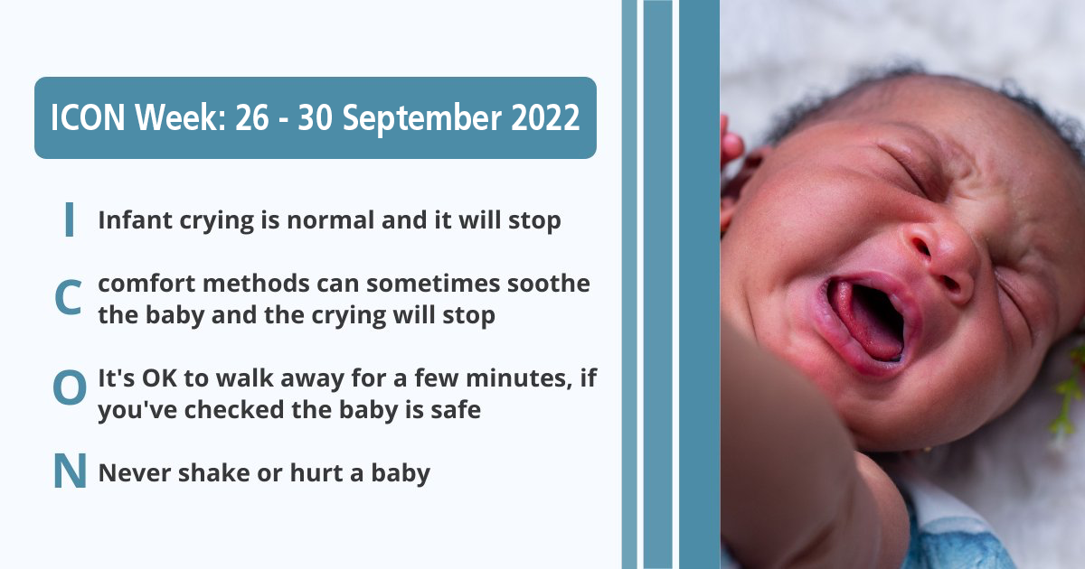

Graphic 7
