Low Level Concern Form

Please use this form to share any concern – no matter how small, and even if no more than causing a sense of unease or a ‘nagging doubt’ – that an adult may have acted in a way that:
• is inconsistent with the school’s Code of Conduct, including inappropriate conduct outside of work, and
• does not meet the allegation threshold, or is otherwise not serious enough to consider a referral to the LADO.
Remember, a low-level concern is different to an allegation. See the table below for a definition:
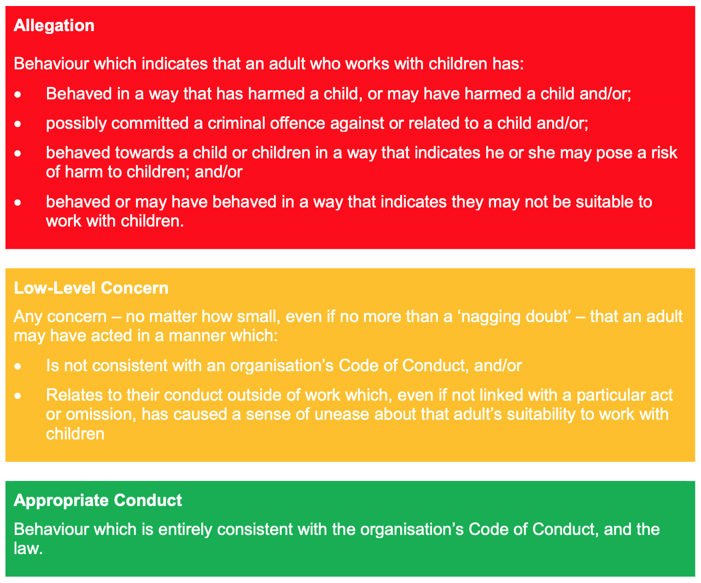

You should provide a concise record – including brief context in which the low-level concern arose, and details which are chronological, and as precise and accurate as possible – of any such concern and relevant incident(s).
Please use a separate sheet if necessary. The record should be signed, timed and dated.
Details of CONCERN :
Name of Staff member :  Signed : | School and Role :  Time and Date :

This part of the form can be used by management to consider and address any unprofessional behaviour and support any individual to correct it at an early stage and to record any subsequent action(s).
Received by :

At [time] : Date :
WAS THE STAFF MEMBER SPOKEN TO? [Good practice will require a response].
NO ☐ - Give a brief but valid reason/explanation for not;

YES ☐ - Please complete detail below - STAFF MEMBER’S RESPONSE TO CONCERN :

ACTION TAKEN :

Was advice/guidance sought from the LADO and/or Human Resources? Yes : ☐ No : ☐

Signed : | Dated :
This record form will be held securely, either digitally or in paper form, in one central file in accordance with the School’s Data Protection Policy.

